Laureen Pearce

laureepearce.bootcamp@justit.co.uk

***Abstract***

*In this assignment, I will be demonstrating what I have learnt about data and data structures, the development of data sets using Excel, and the visualisation of those data sets in Tableau.*

Data Visualisation

***Assignment 1 – 28th August 2024***

Contents

Introduction 2

Data Policies and Principles 2

Part 1 - Visualising Data Using Excel 3

The Data: 3

Step 1: Create a Workbook Password 3

Step 2: Change the Data Type in a Column 4

Step 3: Turn the GDP Sheet into a Table 5

Step 4: Filtering the Table 6

Steps 5 to 7: Creating a Chart for Rank, Country and GDP per Capita 7

Step 8: Creating a Sort for the Top 20 Highest Ranking Countries 11

Step 9: Creating a Bar Chart for the Top 20 Highest Ranking Countries 12

Step 10: Creating Macro Buttons for Print, Save and Copy 13

Step 11: Creating a Word Document: 17

Step 12: Wrapping up the Excel Spreadsheet: 18

Part 2 - Visualising Data Using Tableau 19

Step 1 - Import The Data And Set The Relationships: 19

Step 2 - Checking The Data Types: 21

Step 3 - Building Charts: 21

Step 4 - Building the Dashboards: 41

Step 5 - Creating the Story: 45

Conclusion - Publishing the Story: 46

References 47

## Introduction

Since the advent of the internet and a host of digital platforms, the collection of data has become more than a phenomenon, being both easily accessible and overwhelmingly huge.

Today, a company’s ability to access, visualise, understand and use the data available has become essential for them to gain clearer insights, make better decisions and take the appropriate actions going forward. Therefore, being able to analyse data and present it visually in an understandable way is crucial to this process.

The purpose of this assignment is to show how I would sort, analyse and create a visual report of the data provided in the form of charts and maps by using Excel and Tableau for a client, who has specifically stated that he is colour-blind. I will demonstrate this by providing step-by-step visuals of the processes I will undertake, first in Excel, then in Tableau.

However, I will begin first by discussing in the following section why data security and best practices are a must when dealing with data and what legal requirements have already been put in place to govern the management of data.

## Data Policies and Principles

With the increase of data being collected and processed online globally, there is an increasing need for this data to be handled correctly, ethically, securely and legally (About DAMA UK, n.d.).

The first law in the UK to protect personal data online was established under the Data Protection Act of 1998 (DPA 1998). Generally, the act regulated ‘how and when information relating to an individual may be obtained, used and disclosed’ and gave the individual the legal right to access their own personal data (Lindsay Jordan, Stephen Avila, n.d.). However, as the online environment has since evolved dramatically, a more comprehensive law was needed.

In 2018, the European Union established the General Data Protection Regulation (EU GDPR). At the same time, to bring UK data laws in line with it, the UK updated and replaced their existing DPA 1998 with the new Data Protection Act 2018 (DPA 2018) *(Guide to the General Data Protection Regulation (GDPR), n.d.)*. Then, following the UK’s exit from the EU, the UK General Data Protection Regulation 2020 (UK GDPR) was established, which effectively mirrors the EU GDPR with some minor differences to make it specific to the UK (The DPA 2018 and UK GDPR, n.d.).

In addition to this, the Data Management Association (DAMA UK - (About DAMA UK, n.d.)) provided a set of data management principles to ensure that shared data is being stored, analysed, visualised and presented accurately and consistently across the board

The data principles every business is being encouraged to follow include:

1. Incorporating best practices and secure systems to legally and ethically collect, handle, store and transmit data;
2. Retaining copies, backing up and regularly auditing data;
3. Implementing metadata that provides details about the characteristics and life cycle of the data;
4. Publishing visualisations of data analysis through approved channels;
5. Controlling access to data by placing limits, where applicable, and granting access to the right people at the right time.

(Data Principles, ONS, n.d.)

## Part 1 - Visualising Data Using Excel

I will be working with a data set in Excel called ‘The Wealth of Nations’ for this exercise. I will provide step-by-step text and screenshots to show how I proceed with first organising and transforming the data before producing the data visualisations.

## The Data:

After accessing the ‘Wealth of Nations’ Excel workbook and saving a copy for myself, I examined the data. I could see that there were three sheets of data, each covering a different category: GDP, Life Expectancy, and Smartphones. They each contained 4 columns of data: Rank, Country, Category, and the year the information was obtained.

## Step 1: Create a Workbook Password

Before making any changes to the data, I applied a password to protect the Excel workbook, as follows:

1. In the Review Tab, I selected Protect Sheet in the Protect section: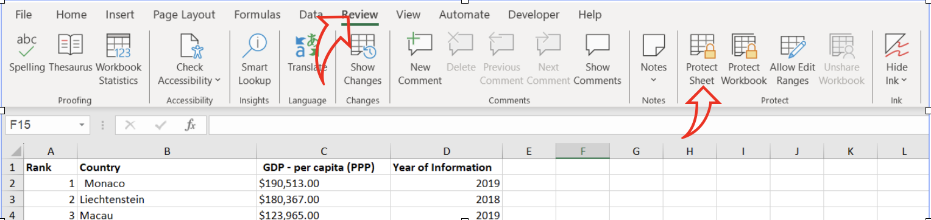
2. I set the following password: *LPearce005* in the field as shown below: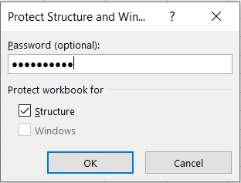

## Step 2: Change the Data Type in a Column

1. To change the data type in Column C, I selected the column for ‘GDP - per capita’: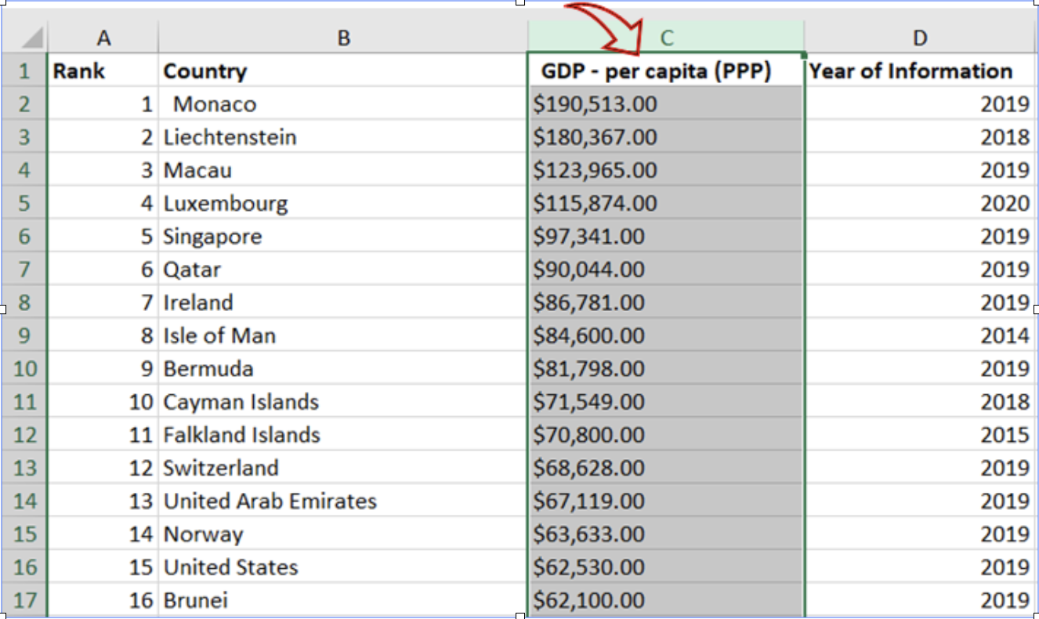
2. I clicked on ‘Format’ in the Cells section under the Home Menu to open up the Format Cells window (this can also be done by right-clicking on the column header and selecting ‘Format Cells from the drop-down):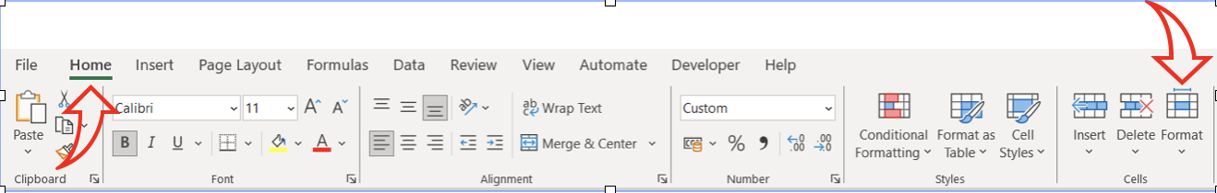
3. I selected ‘Currency’ in the Category box, the ‘£’ symbol in the ‘Symbol’ field and ensured the decimal place was set to ‘2’: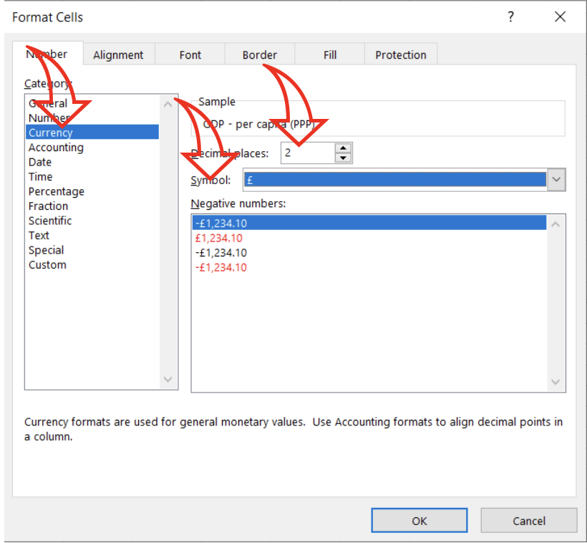
4. Column C now appears with the British Pound currency sign instead of the original dollar sign: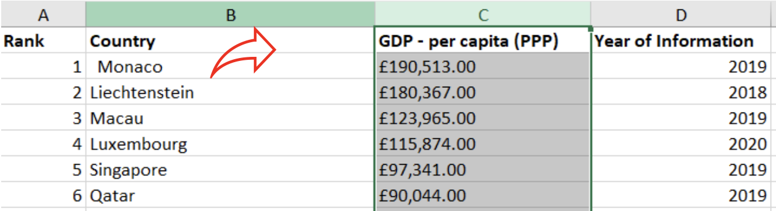

## Step 3: Turn the GDP Sheet into a Table

1. First, I selected the columns with the data, then clicked on ‘Format as Table’ in the Home Menu: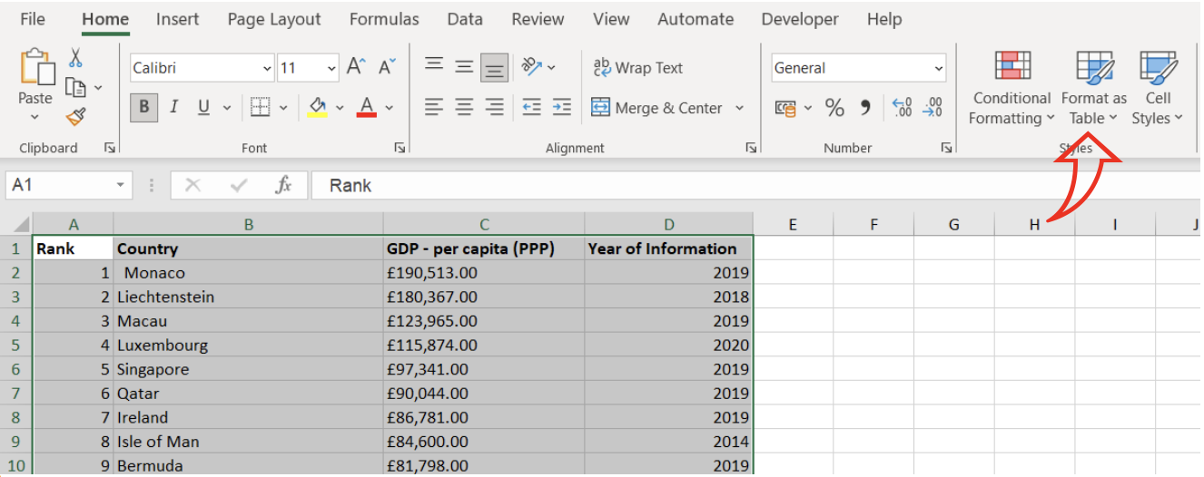
2. I selected ‘Blue, Table Style Medium’, ticked the box for ‘My table has headers’, and clicked ‘OK’ to finish: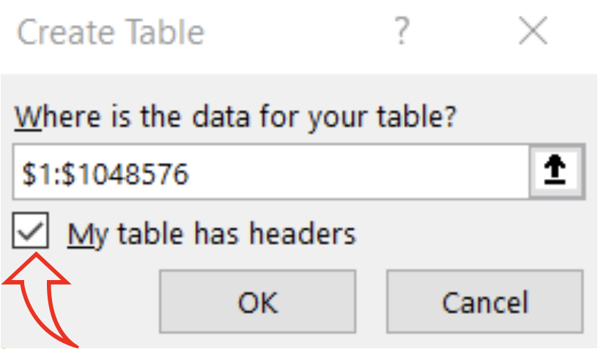
3. The result appeared as follows: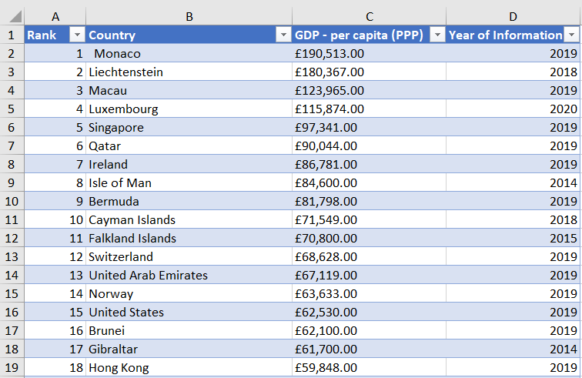

## Step 4: Filtering the Table

1. To filter the table to display only the data for 2019, I click on the down arrow for the ‘Year of Information’ column and clicked in the ‘Select All’ box to deselect everything below it: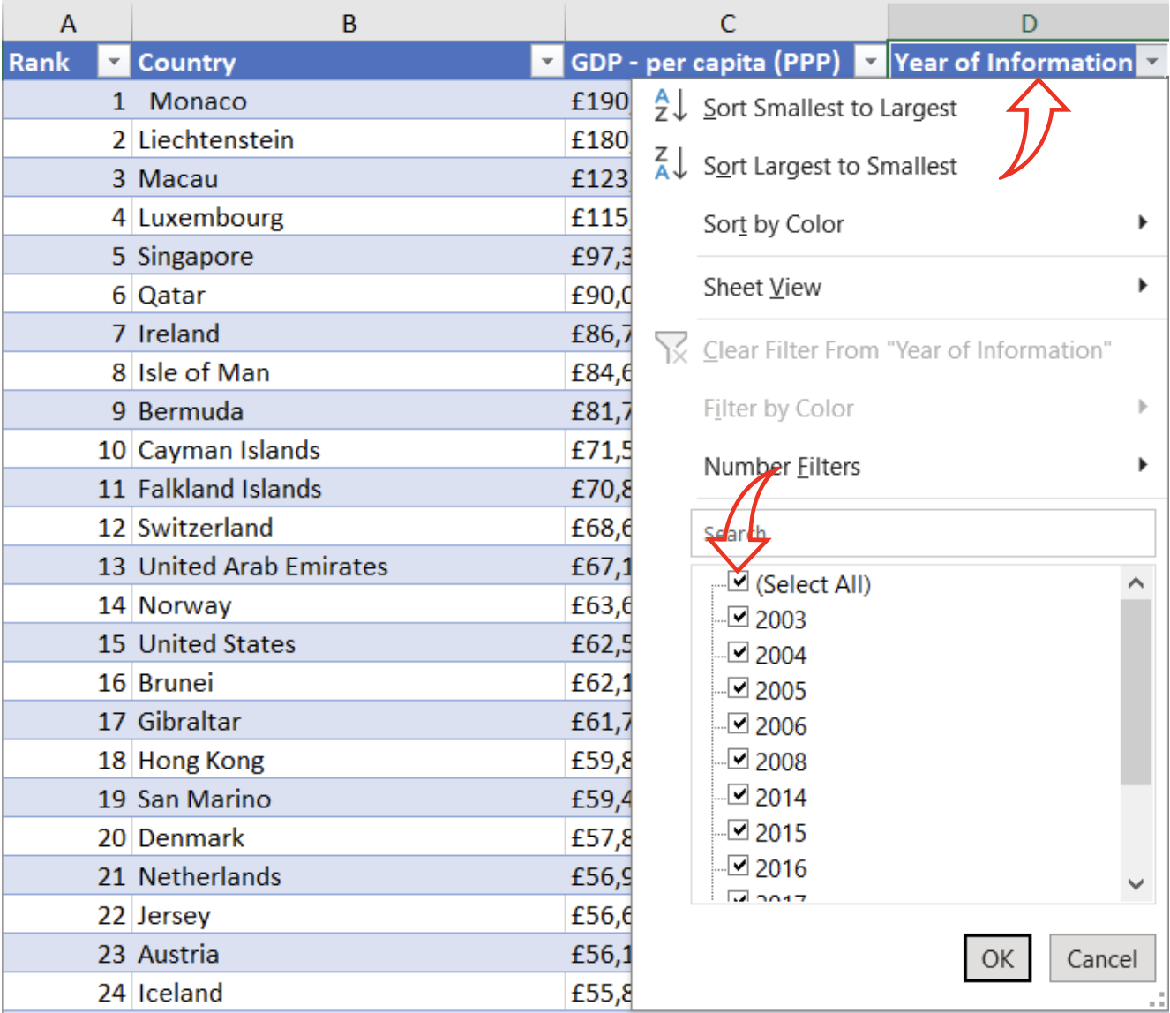
2. I then selected only the tick box for ‘2019’ and clicked ‘OK’: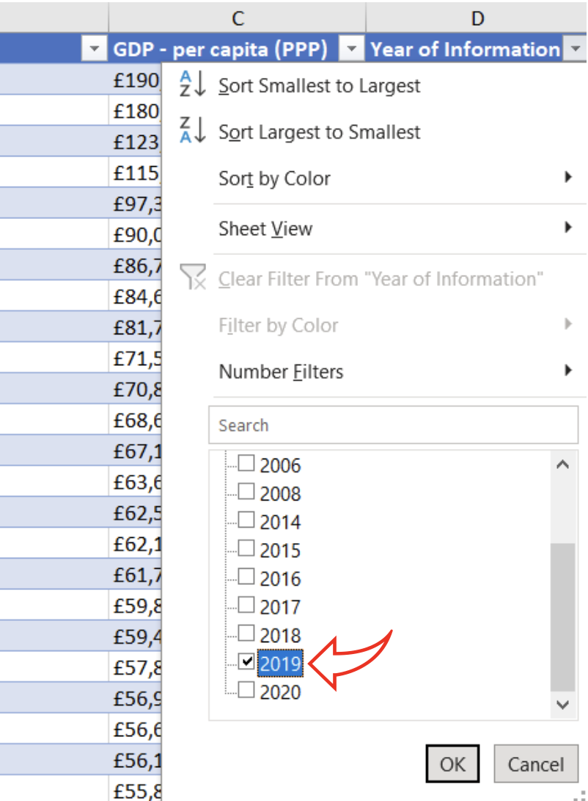
3. The result appeared as follows, with 229 lines of data for the year 2019: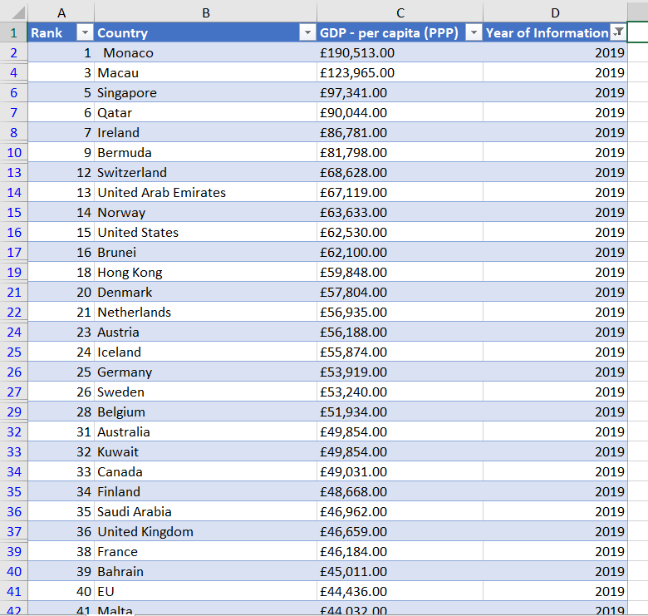

## Steps 5 to 7: Creating a Chart for Rank, Country and GDP per Capita

1. I selected the three columns labelled ‘Rank’, ‘Country’ and ‘GDP - per Capita (PPP)’: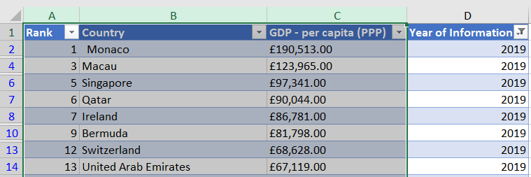
2. Going to the ‘Insert’ tab, I selected ‘Recommended Charts’ in the ‘Charts’ section and clicked on the ‘All Charts’ tab. I selected the ‘Column’ chart on the lefthand side, then clicked on ‘Clustered Column’ and chose the righthand side example: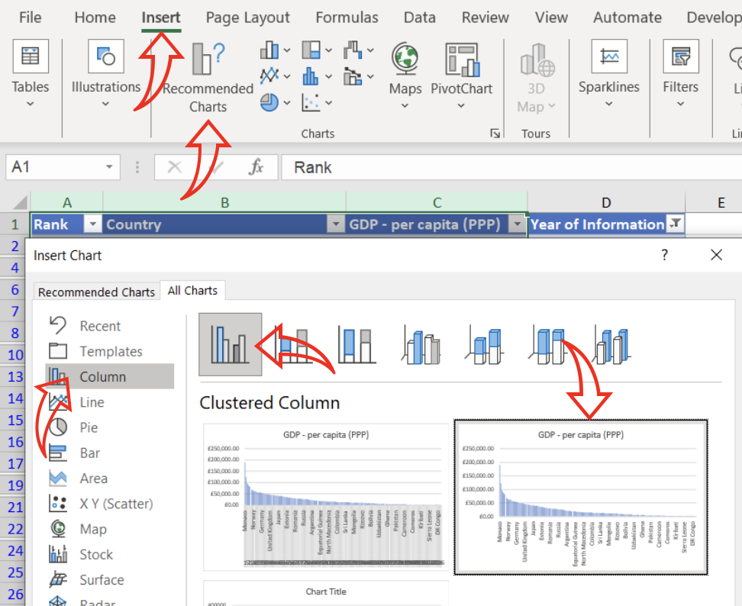
3. I continued to edit my chart as follows:
   1. I double-clicked on the existing title to amend it to ‘The Wealth of Nations Ranked’ and changed the font to ‘Aptos Black’ and the font size to 16 points. Using the ‘Format Chart Title’ section to the righthand side, I changed the font to green and set the alignment to ‘Top-Centred’: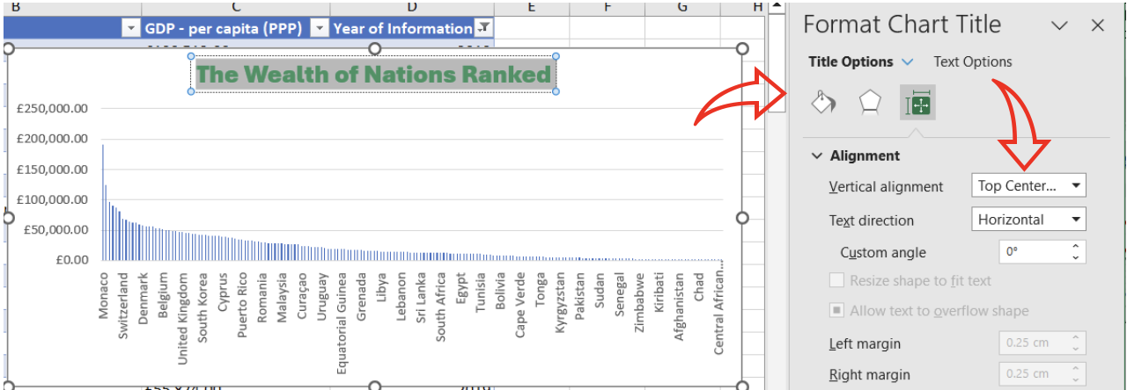
   2. To add both horizontal and vertical axis titles, I clicked on ‘Add Chart Element’ in the Chart Design section and formatted the axis titles by double-clicking on them: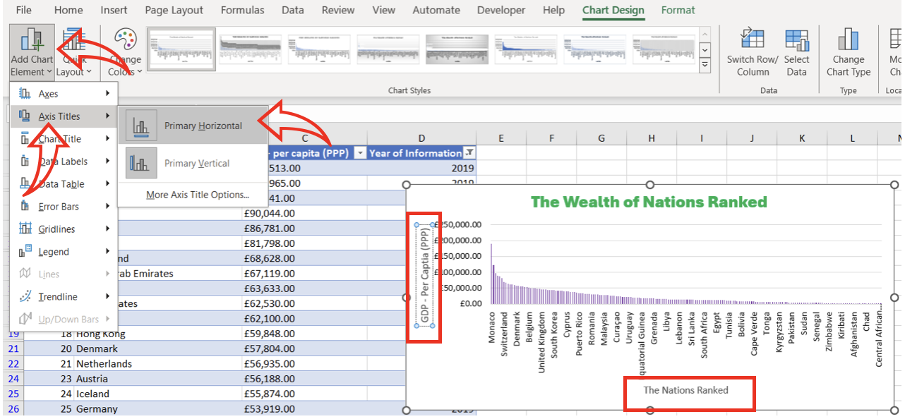
   3. Finally, using the ‘Format Chart Area’ to the righthand side, I made the chart visually appealing: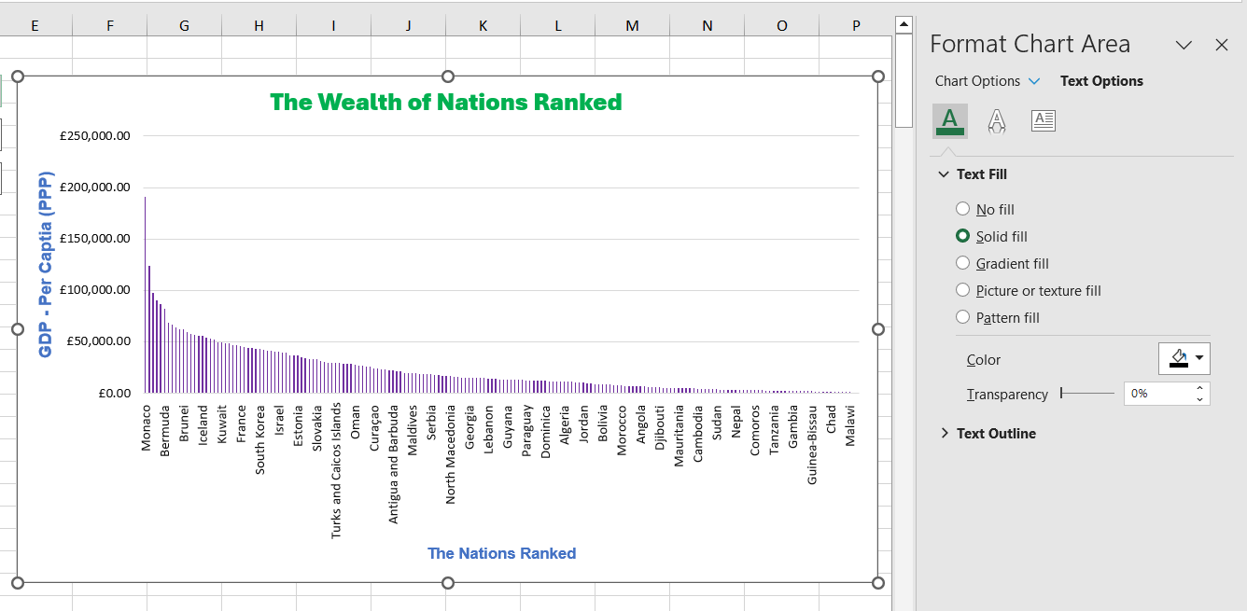
4. I created a new worksheet by clicking on the ‘+’ button at the bottom of the Excel workbook, and renamed it ‘Nations Ranked GDP’ so that I could move the chart to it as follows:
   1. To bring up the floating menu I right-clicked on the chart and selected ‘Move Chart: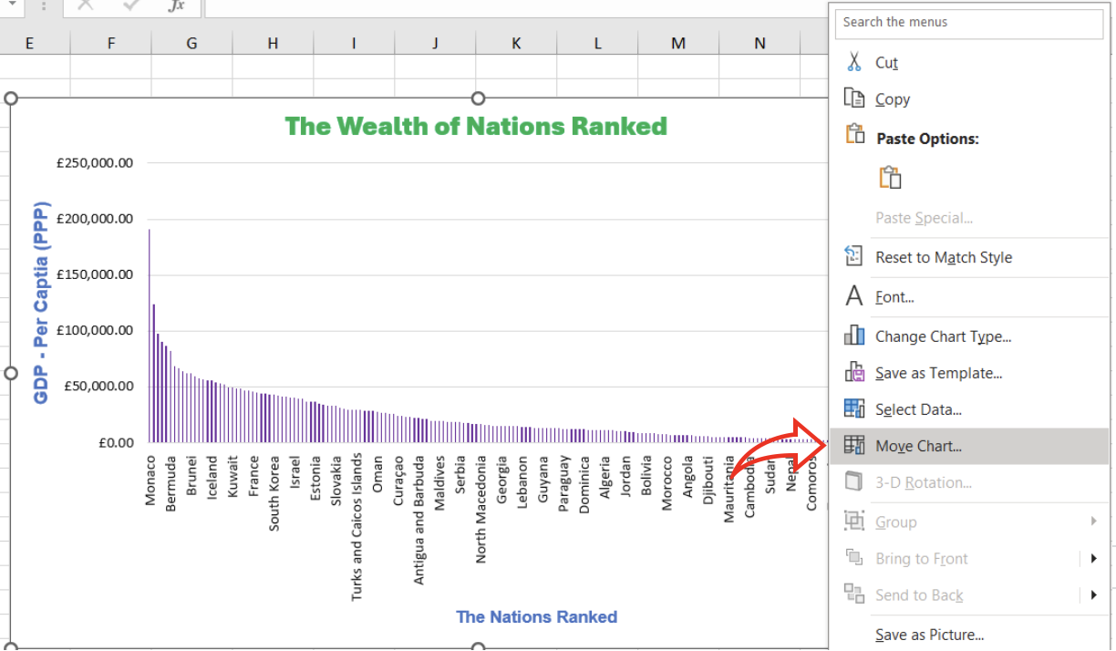
   2. In the following window. I selected ‘New Sheet’ and typed in the name I had already given my sheet, and clicked ‘OK’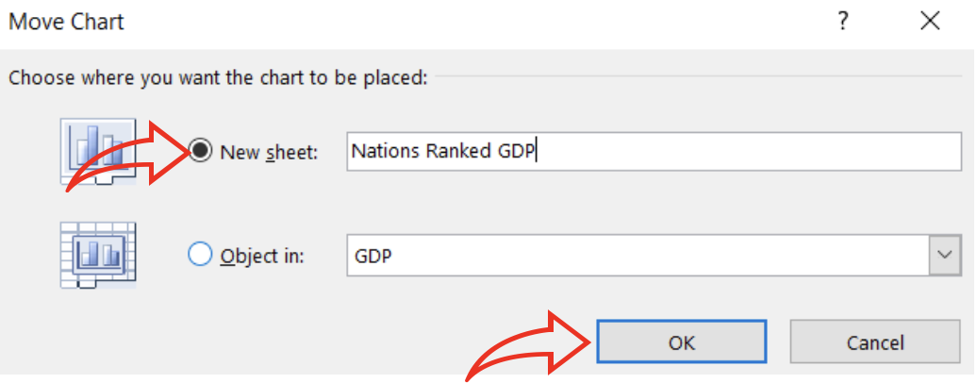

## Step 8: Creating a Sort for the Top 20 Highest Ranking Countries

1. I returned to the original GDP Sheet and created a sort for the top 20 highest ranking countries by clicking on the down arrow in the ‘GDP – per capita (PPP)’ column, then sele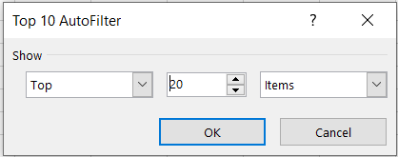cting ‘Number Filters’ and ‘Top 10’ as follows: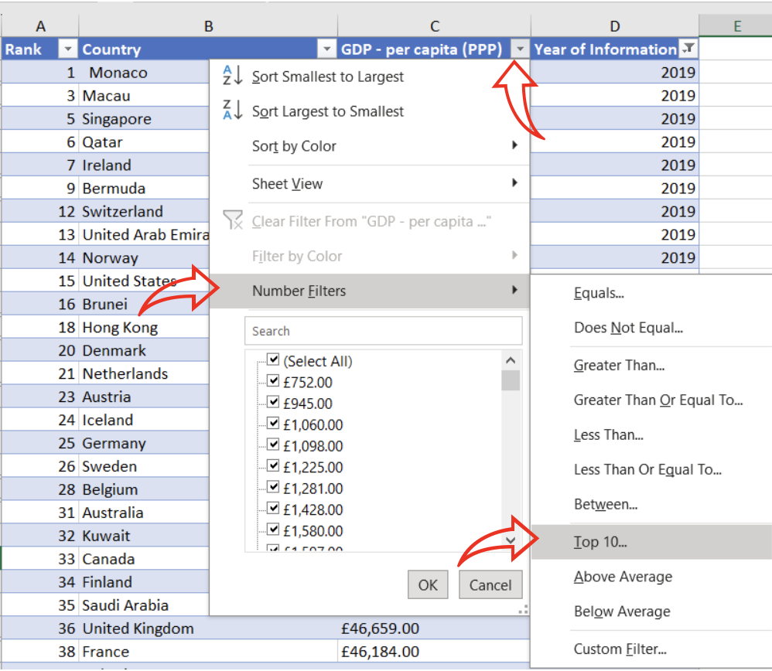
2. In the ‘Top 10 AutoFilter’ window, I changed the number in the middle field to 20 and clicked ‘OK’:
3. The result was my table now had only 20 rows showing the highest-ranked countries in 2019: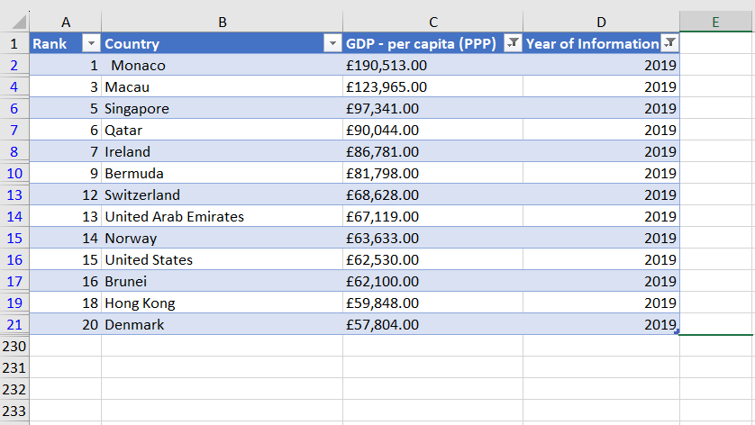

## Step 9: Creating a Bar Chart for the Top 20 Highest Ranking Countries

1. With the ‘Country’ and ‘GDP – per capita (PPP)’ columns highlighted, I clicked on the chart icon in the ‘Insert’ menu and in the ‘Charts’ section and selected the ‘2-D Bar’ option: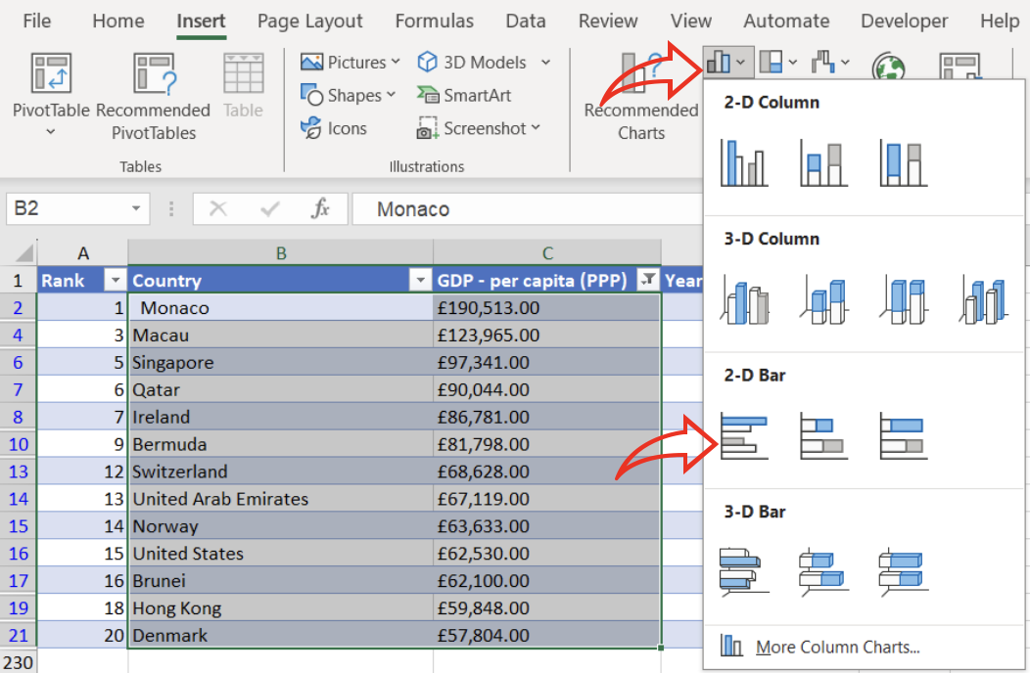
2. After giving the chart a new heading and making it visually appealing as I did for the previous chart, I positioned it under the table as follows: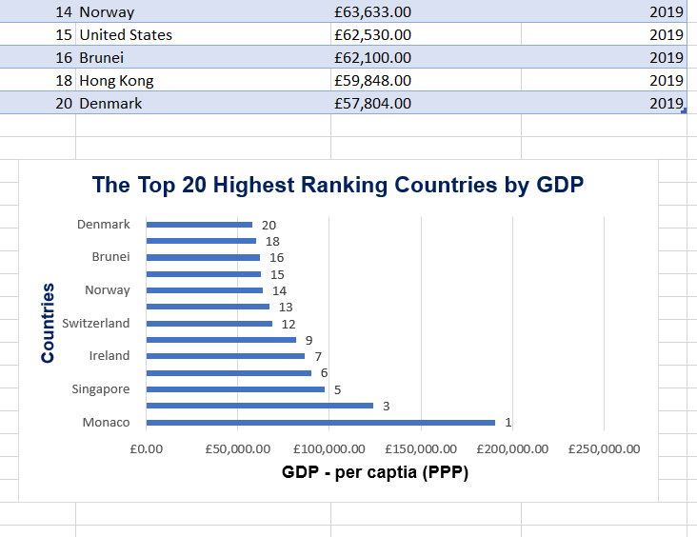
3. I highlighted the area behind the chart and selected the cyan colour fill from the ‘Fill Colour’ icon in the ‘Home’ menu: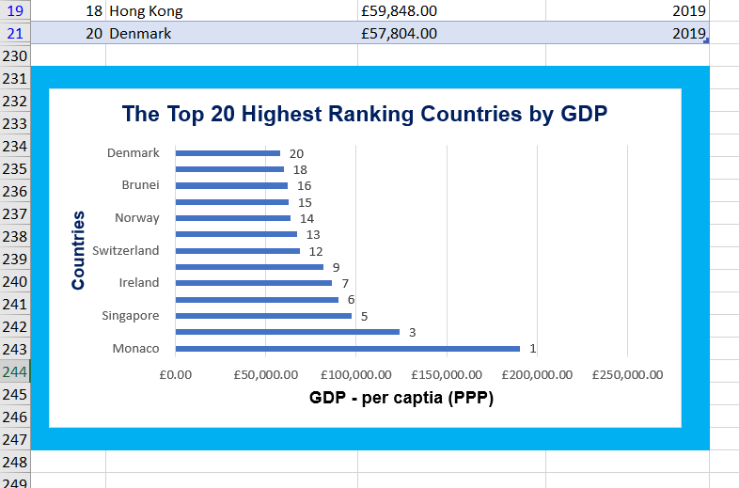

## Step 10: Creating Macro Buttons for Print, Save and Copy

1. To create the buttons, I first went to the ‘Insert’ menu and selected ‘Icons’ from the ‘Illustrations’ menu: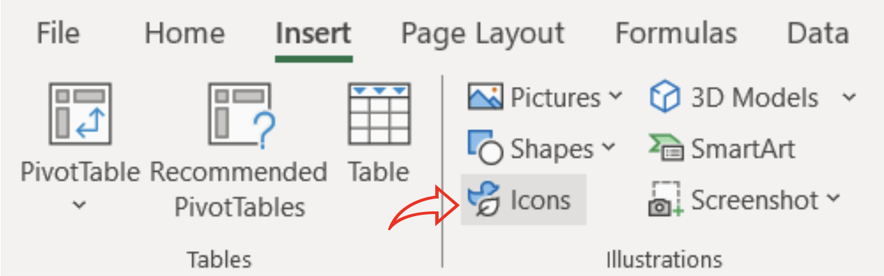
2. In the Stock Images window, I selected the ‘Technology and Electronics’ category and chose the following icons for my ‘Print’, ‘Save’ and ‘Copy’ buttons: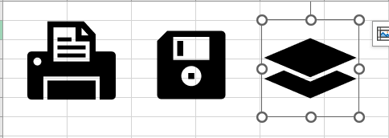
3. I added some text on top of the icons using text boxes, grouped each icon and textbox together and formatted the colour and appearance using the ‘Format Shape’ window. I positioned the icons below my Bar Chart: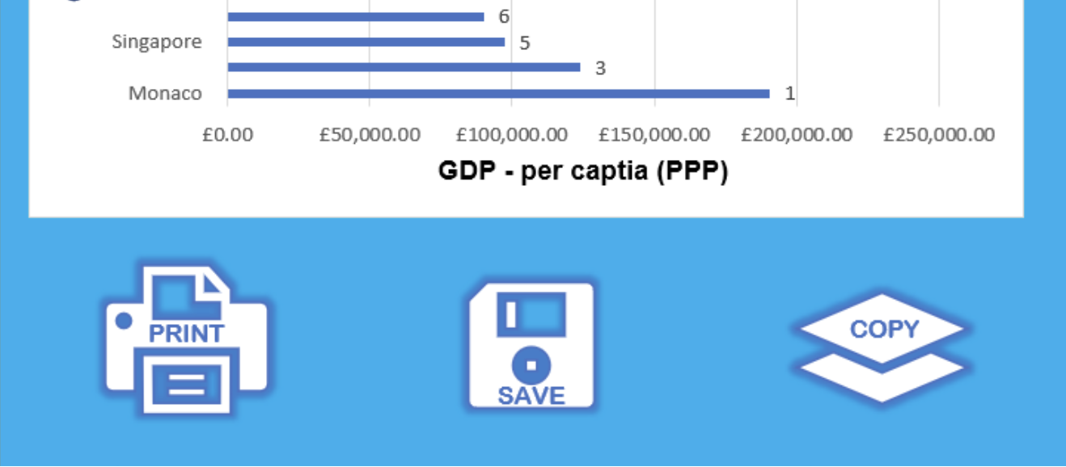
4. For the ‘Copy’ macro, I went to the View Menu, clicked on the dropdown for the ‘Macros’ and selected ‘Record Macro: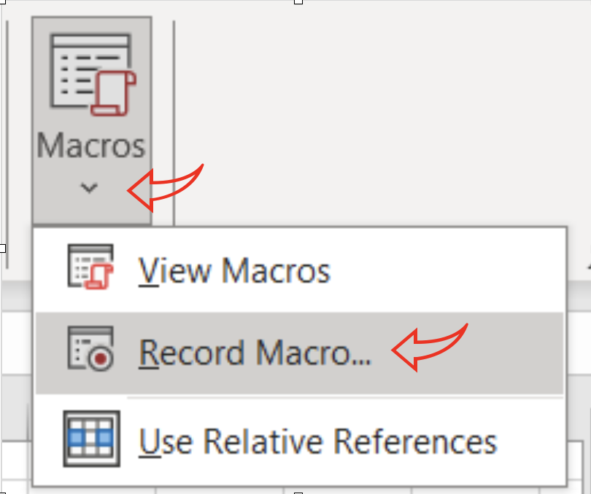
5. In the ‘Macros’ window, I labelled the macro as ‘CopySelection’, assigned ‘c’ to the Ctrl+ box and clicked ‘OK’: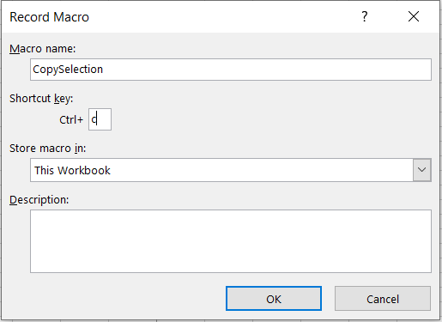
6. I selected the area including my GDP table and Bar Chart: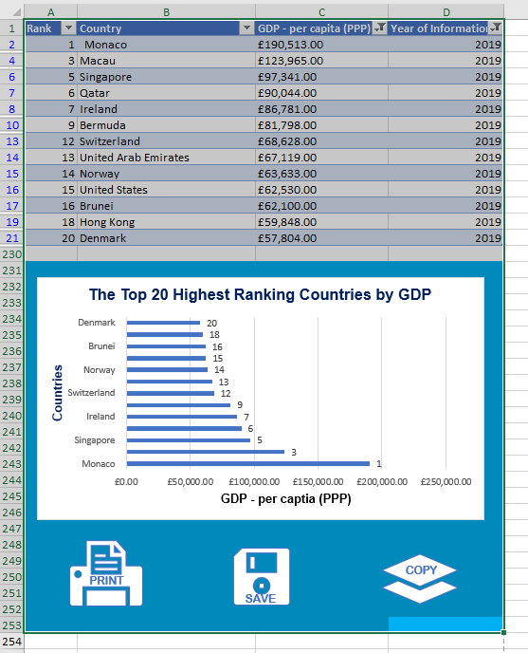
7. I right-clicked on the selection to bring up the floating menu and clicked on ‘Copy’: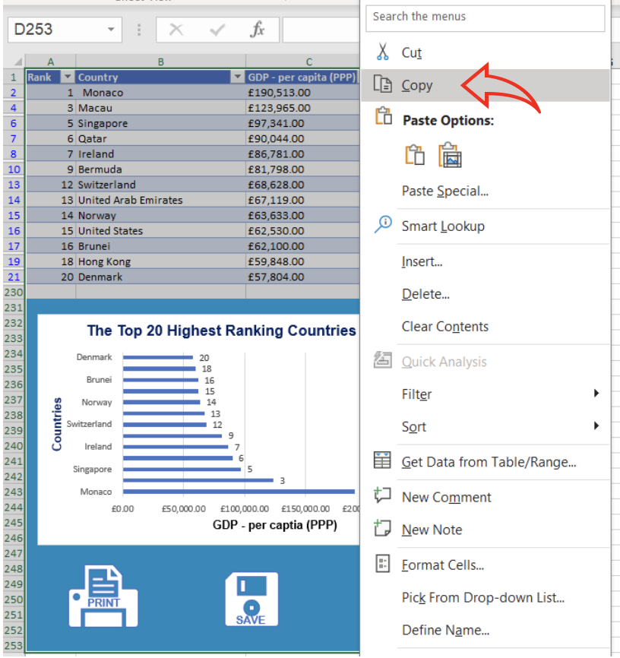
8. I went back to the Macros icon in the View menu and click on ‘Stop-recording: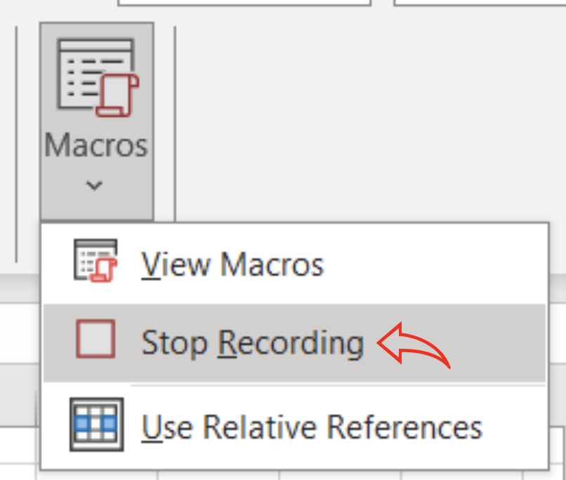
9. Selecting the ‘Copy’ button I had created, I right-clicked to reveal the floating menu and selected ‘Assign Macro’: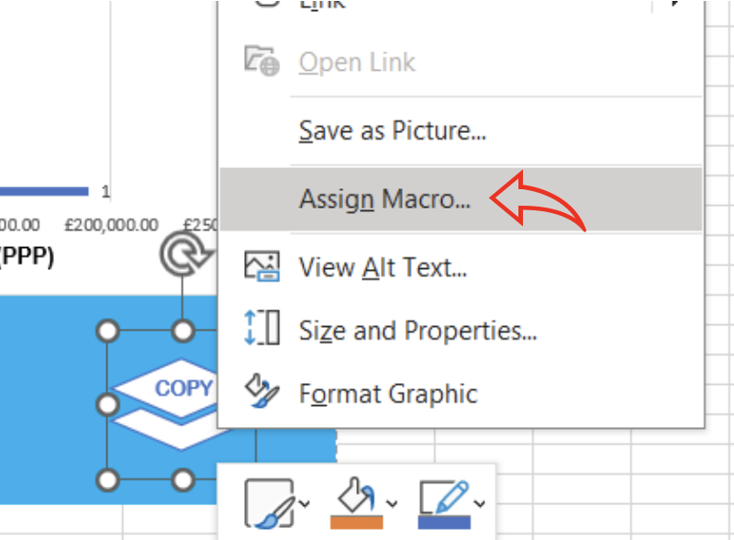
10. And selected ‘CopySelection’ from the ‘Macro Name’ box, clicking ‘OK’ to complete the process: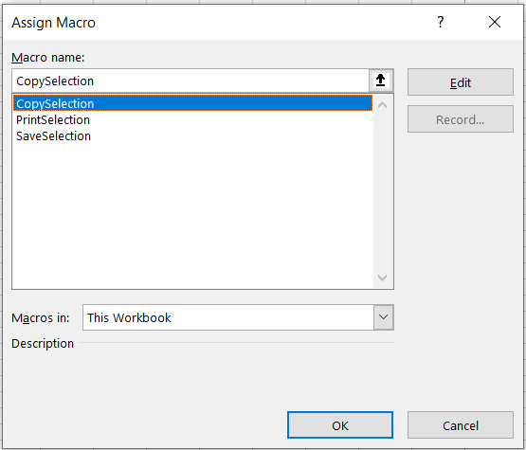
11. I did the same process to create the macros for the ‘Print’ and ‘Save’ icons as can be seen above.

## Step 11: Creating a Word Document:

1. After creating the macro buttons, I selected the Table and Bar Graph for GDP in my worksheet and used the copy macro to copy the selection: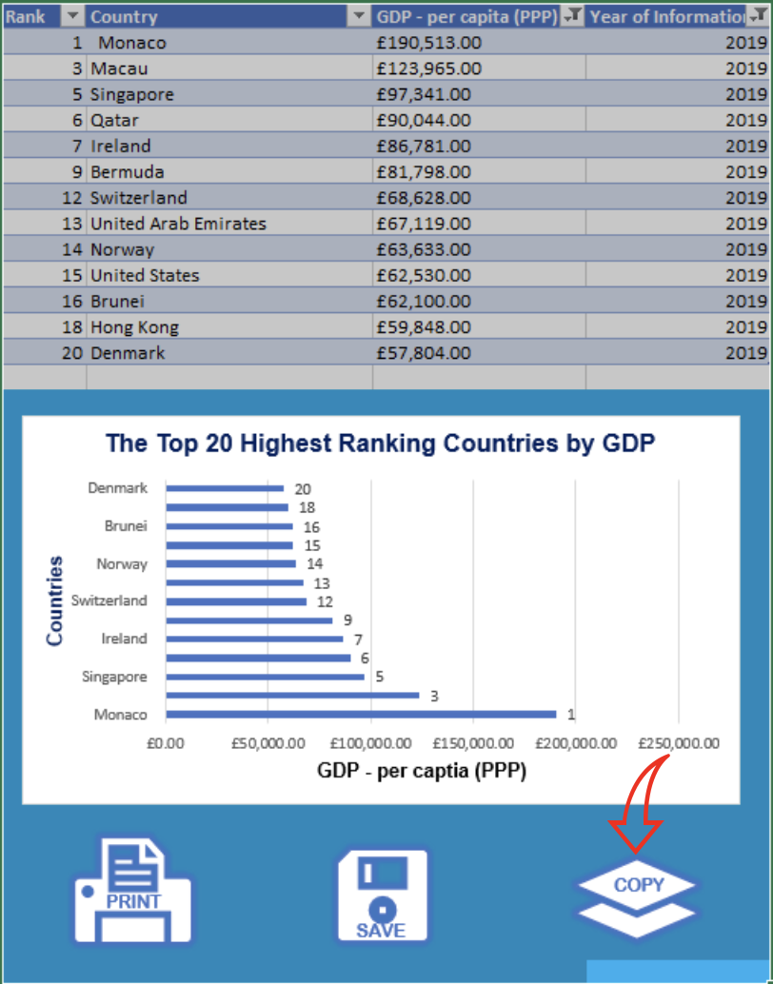
2. I pasted this into a Word document and added a title to the top of the page as follows: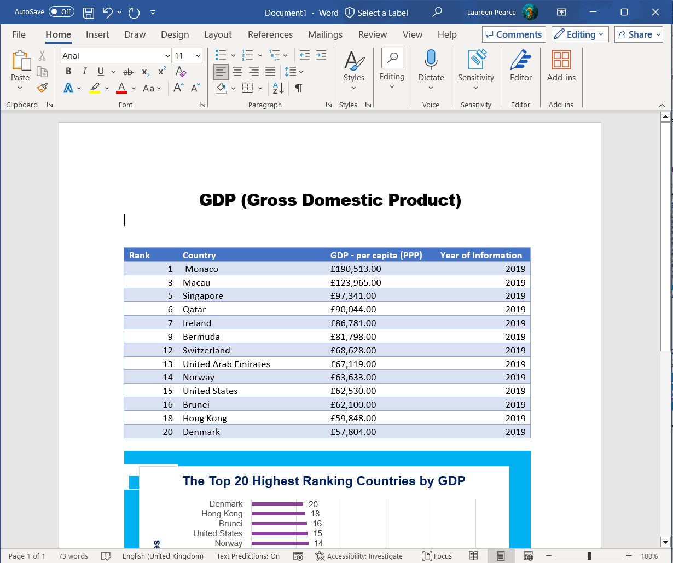
3. And saved it as ‘Word Gross Domestic Product Report 1’: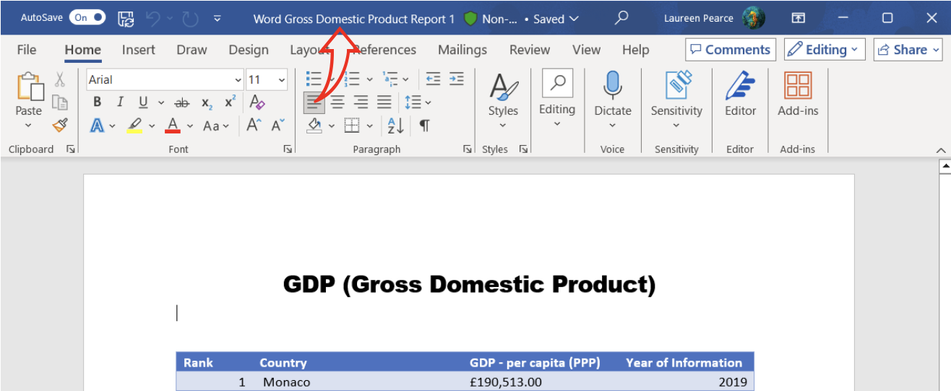

## Step 12: Wrapping up the Excel Spreadsheet:

1. Going back to my Excel ‘GDP’ spreadsheet, I selected ‘Page Layout’ from the ‘View’ menu to add a header and footer: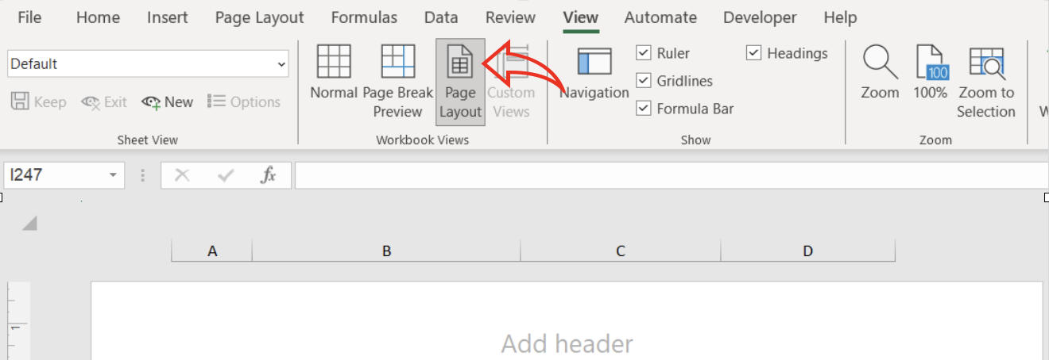
2. I added my name and GLA DATA1 in the header boxes as follows: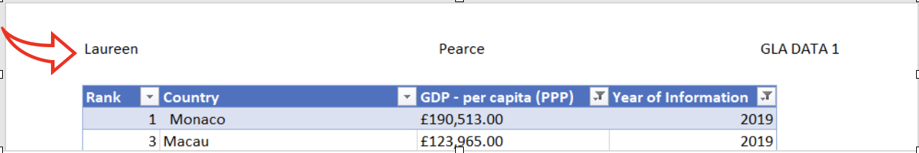
3. I then added the date, ‘Assignment 1’ and ‘Data Visualisation to the footer boxes, as follows: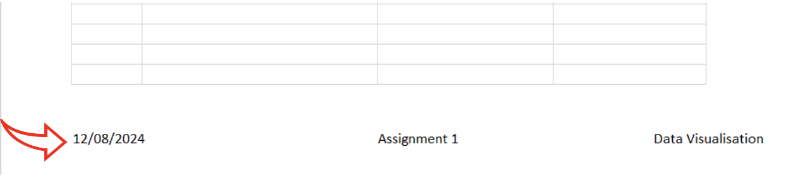
4. Finally, I returned back to ‘Normal’ view and save my Excel sheet as ‘Excel Gross Domestic Product Report 1’.

## Part 2 - Visualising Data Using Tableau

Now that I have formatted the data in my Excel sheet, ‘Wealth of the Nations’, I will now use Tableau to produce the visuals required for my report.

The client has requested a visual report that will show the Excel data in the form of charts and maps using Tableau to the client’s requirements, keeping in mind the fact he is colour-blind.

## Step 1 - Import The Data And Set The Relationships:

1. I opened up Tableau and went to ‘File - Open’, located my Excel file and clicked ‘Open’: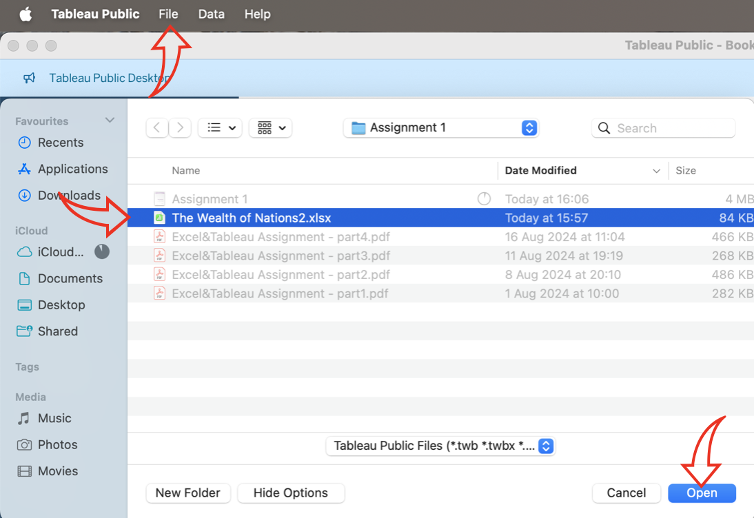
2. In the next window, I selected ‘Life Expectancy’ from the lefthand side and dragged it to the canvas: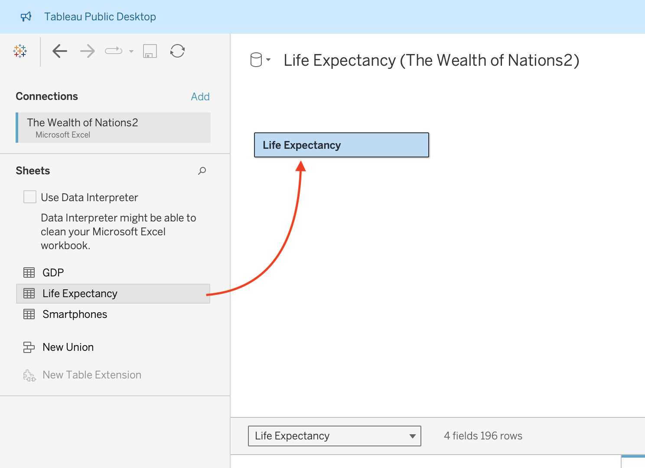
3. I did the same with ‘Smartphones’: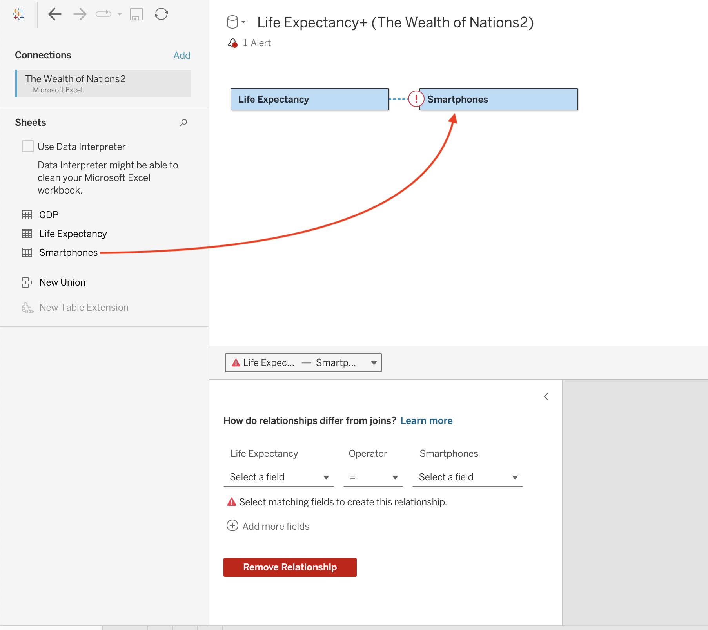
4. In the ‘Relationships’ section below the canvas, I amended the fields below ‘Life Expectancy’ and ‘Smartphones’ to ‘Country’, and the ‘Operator’ field between them to show ‘=‘, to establish the link between the two spreadsheets: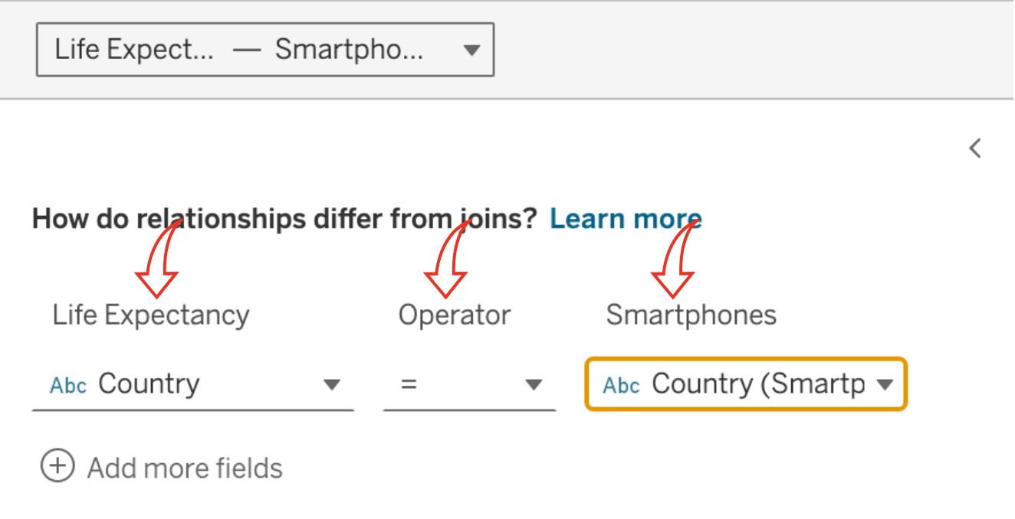
5. I did the same with ‘GDP’ so that the end result looked like this: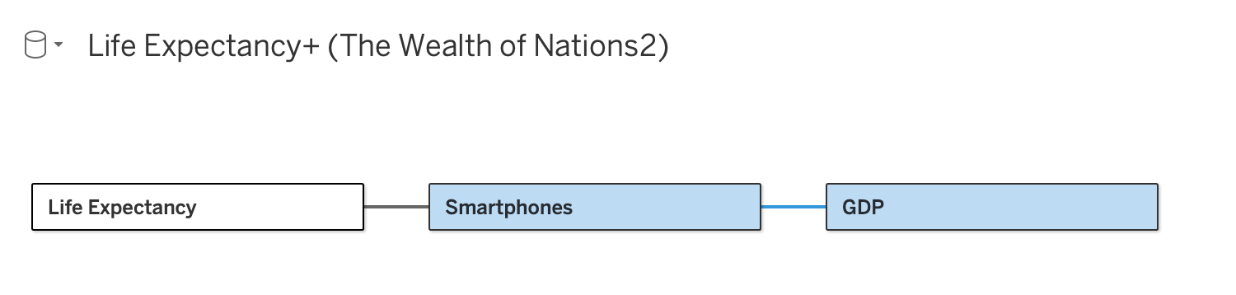
6. An alternative means of representing the relationship between the spreadsheets can also arranged as follows, which is the format I went with: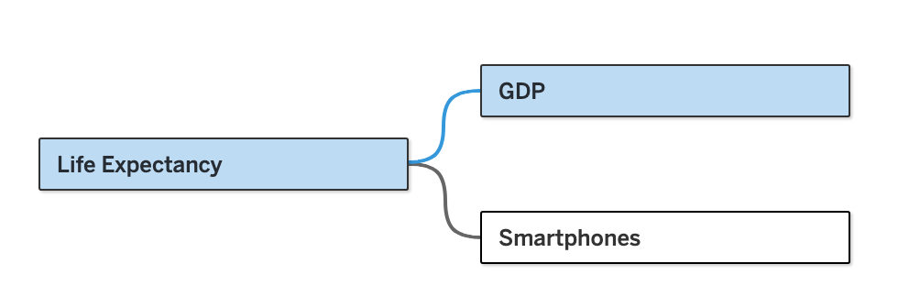

## Step 2 - Checking The Data Types:

1. Selecting the ‘Life Expectancy’ box in the canvas, I checked the data types in the display section on the righthand side below the canvas, by clicking on the symbols in front of the column headers. I change the Data Type to ‘Date’ in the ‘Date of Information’ column: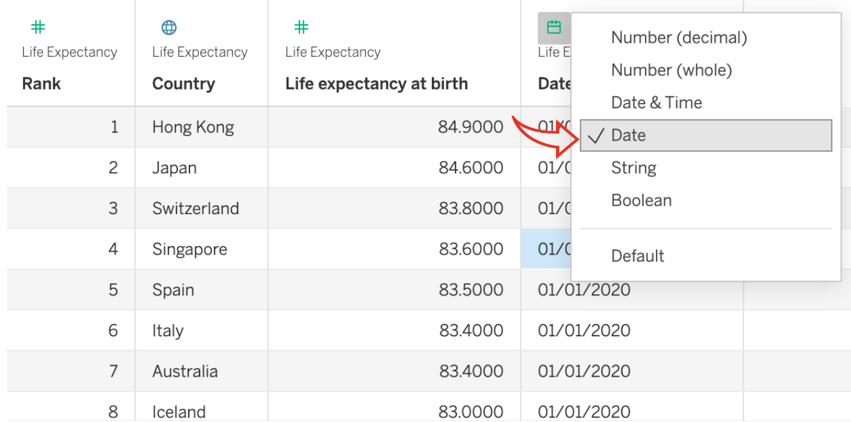
2. I did the same for the other two spreadsheets to ensure the data types were correct.

## Step 3 - Building Charts:

1. For the first visual, I want to show which top 20 countries has the highest number of smartphone users. First, I moved ‘Country (Smartphones)’ from the lefthand side to the ‘Column’ field at the top, and the ‘Smartphone Users’ into the ‘Rows’ field at the top: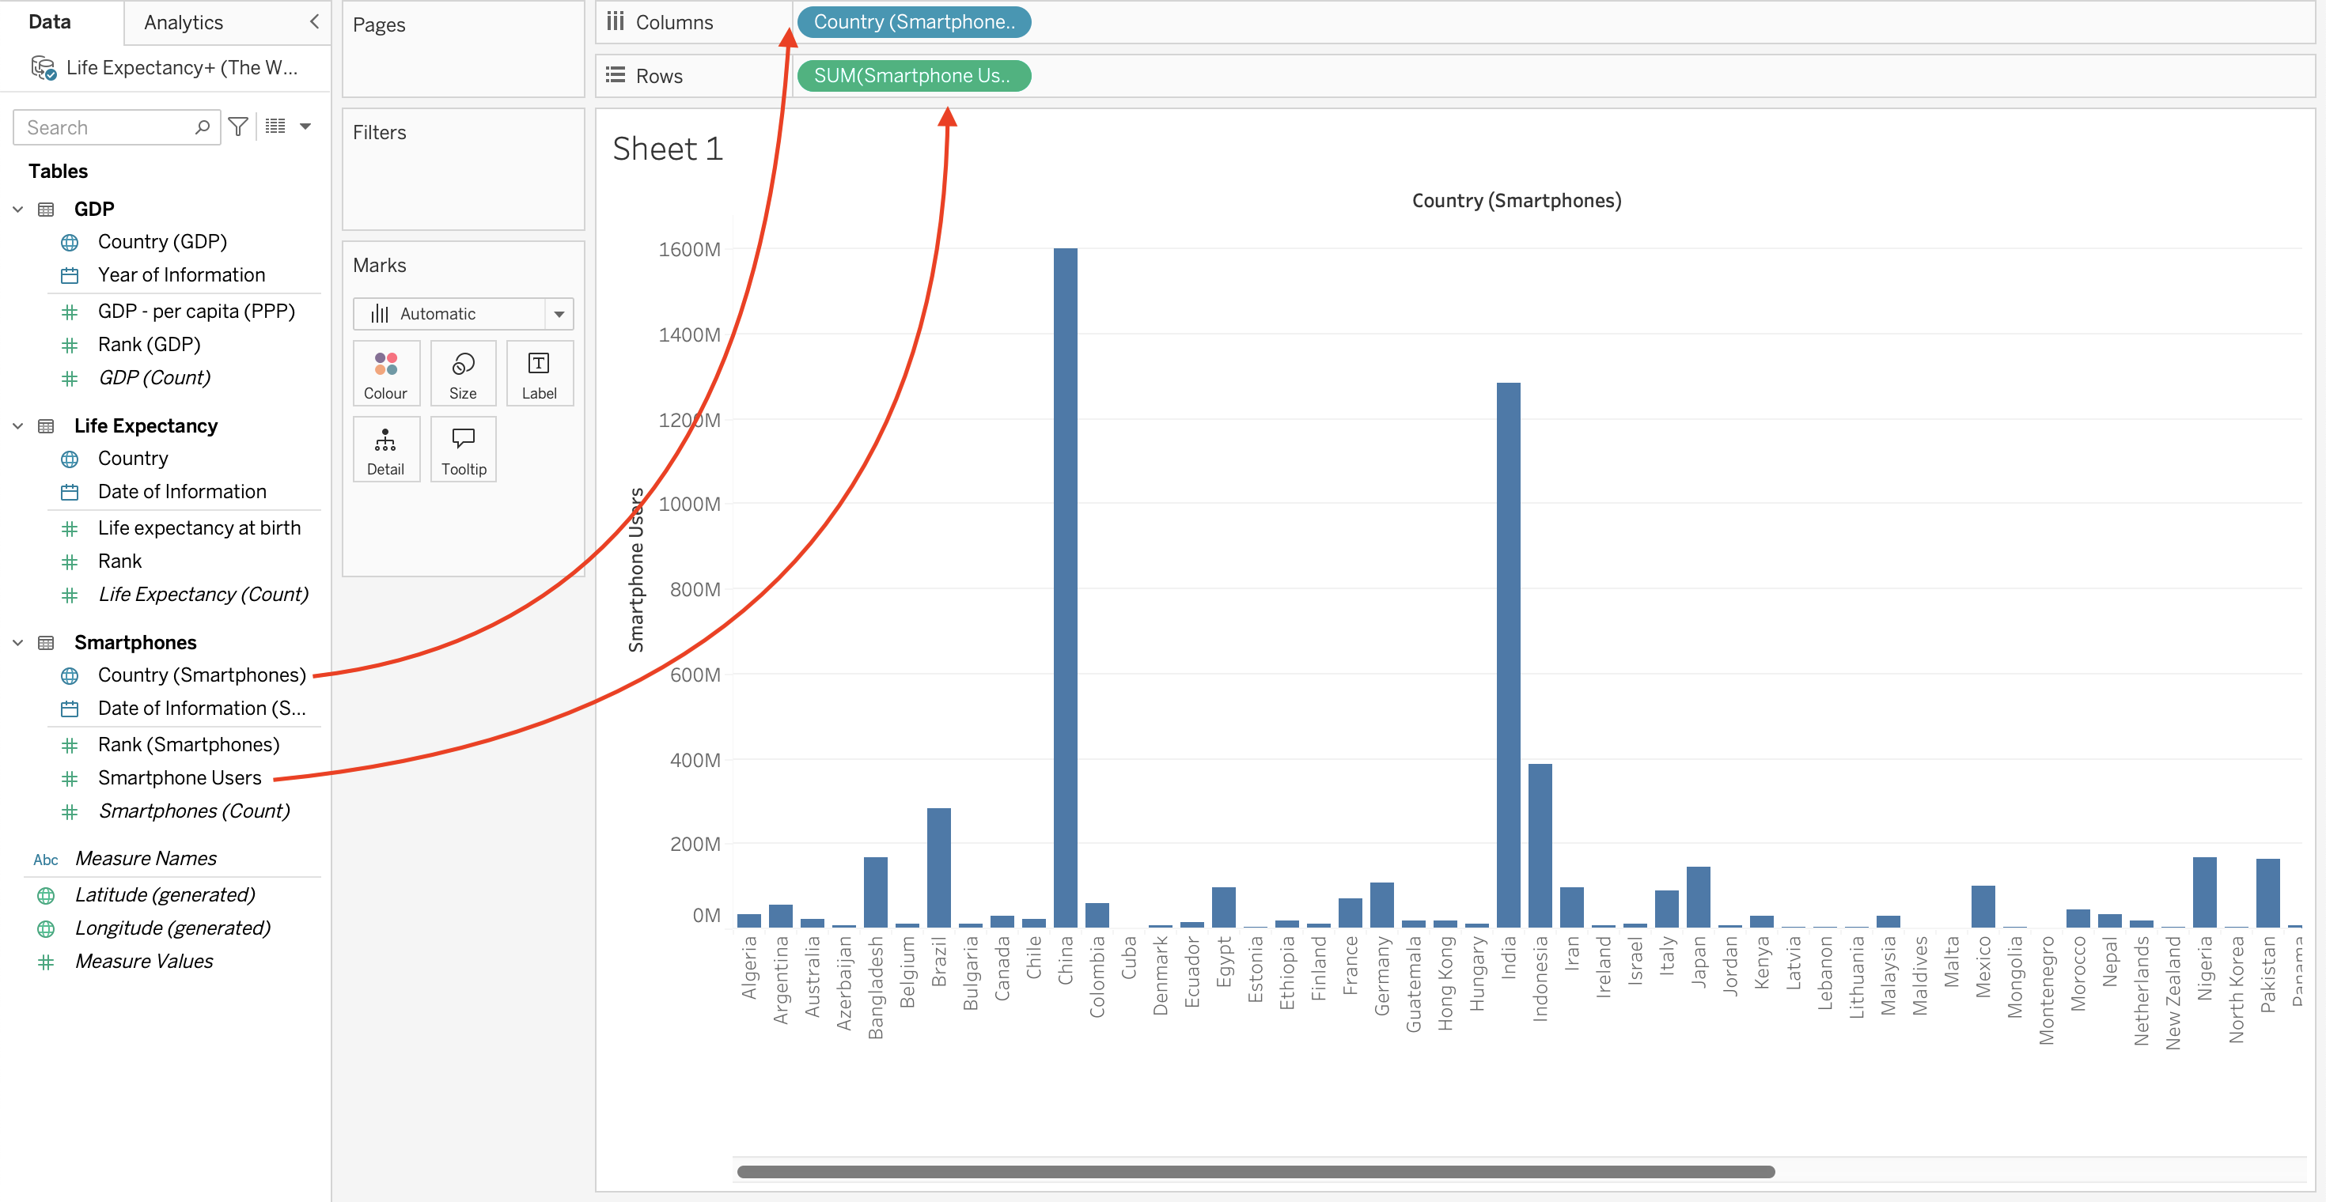
2. Clicking on the down arrow of ‘Country (Smartphones)’ at the top, I selected the ‘Filter’ option: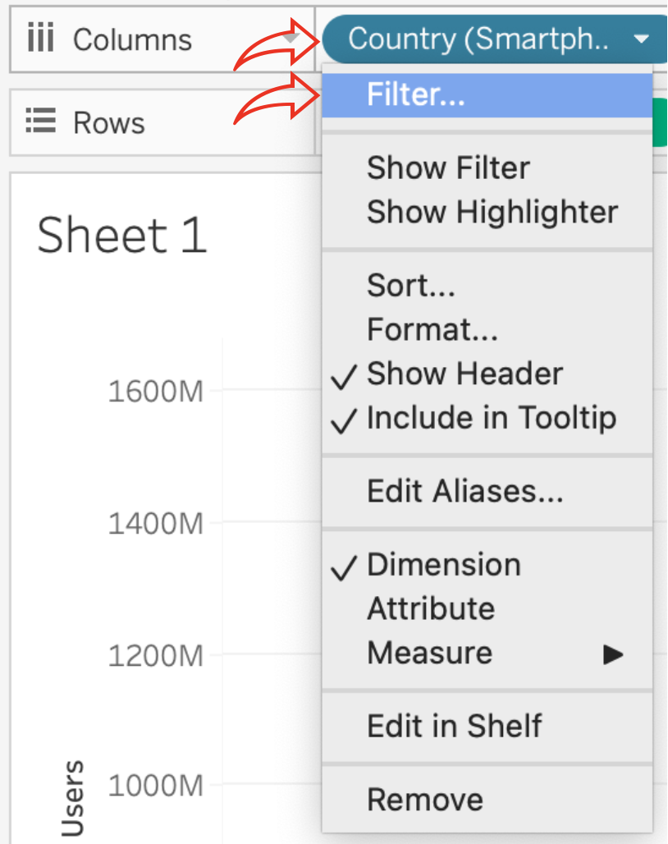
3. In the next window, I clicked on ‘Top’ and ‘By Field’. I changed the number to ’20’ to sort the chart by the top 20 countries, and clicked ‘OK’: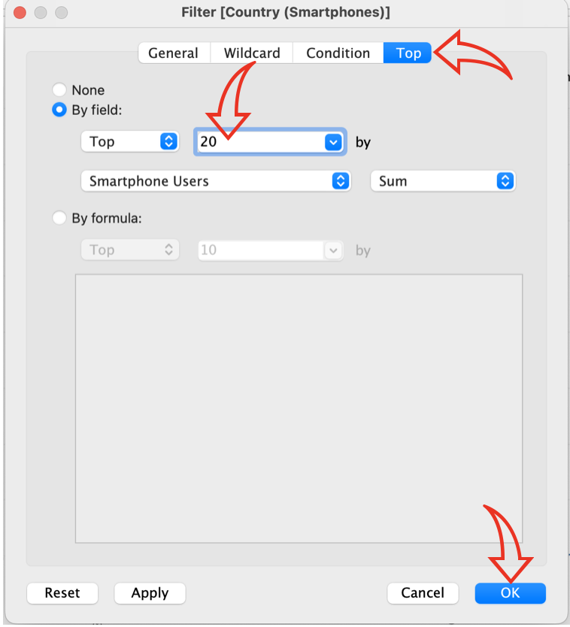
4. The result looked like this: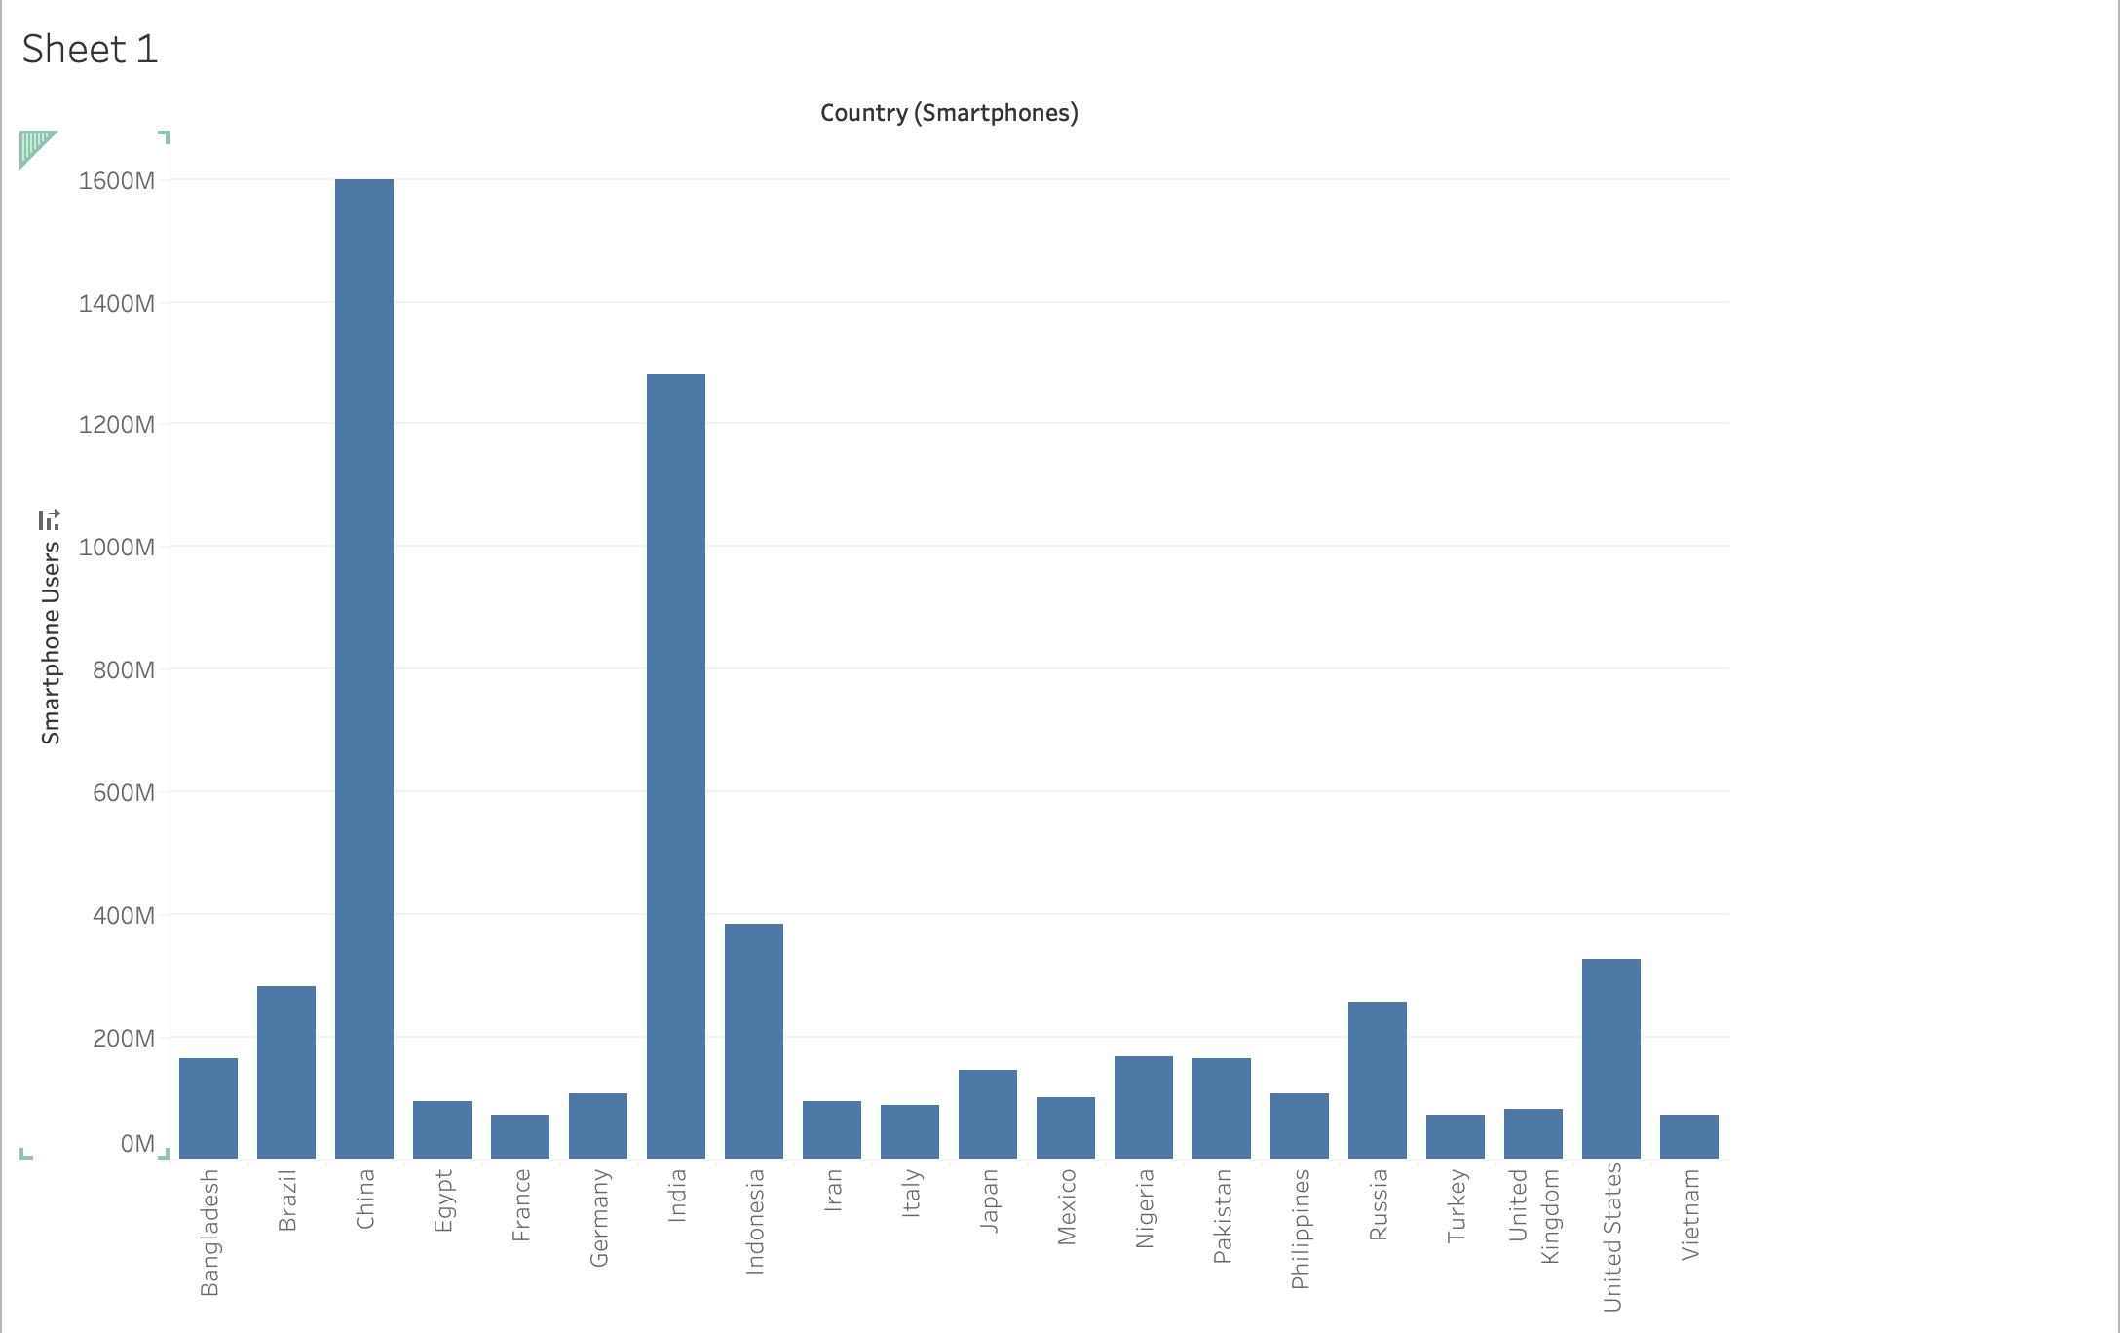
5. In the ‘Filters’ box on the left of the graph, I clicked on the down arrow and selected ‘Sort’: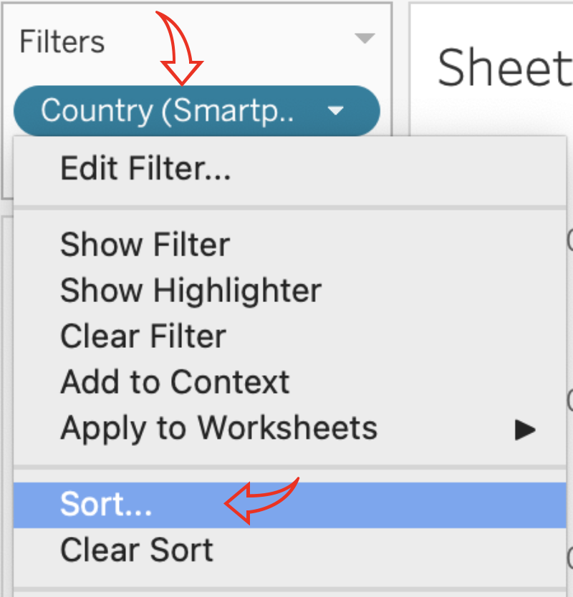
6. In the ‘Sort’ window, I changed the ‘Sort By’ to ‘Field’, the ‘Sort Order’ to ‘Descending’ and closed the window by clicking the ‘X’ at the top: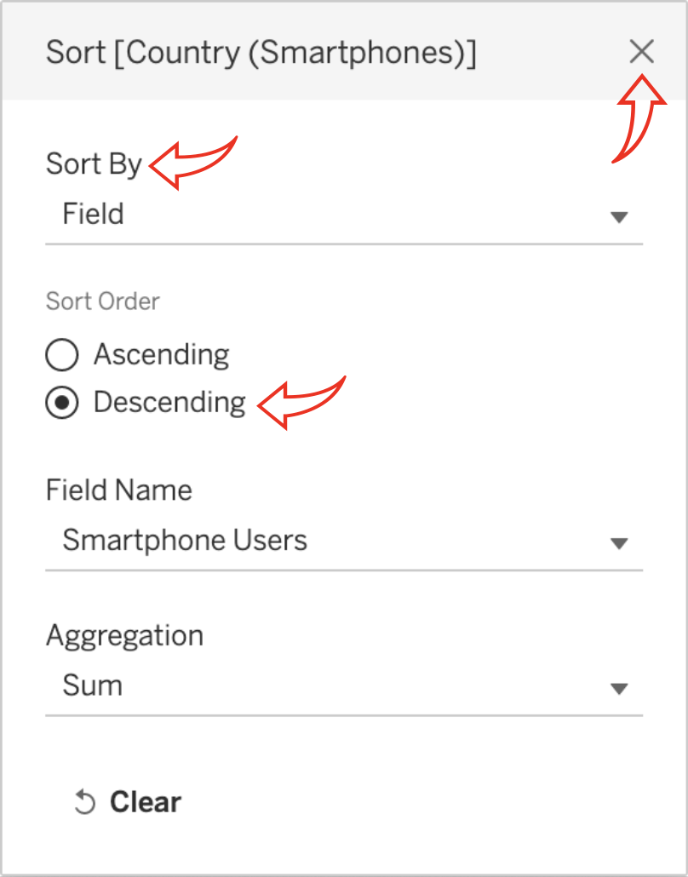
7. The graph now looked like this: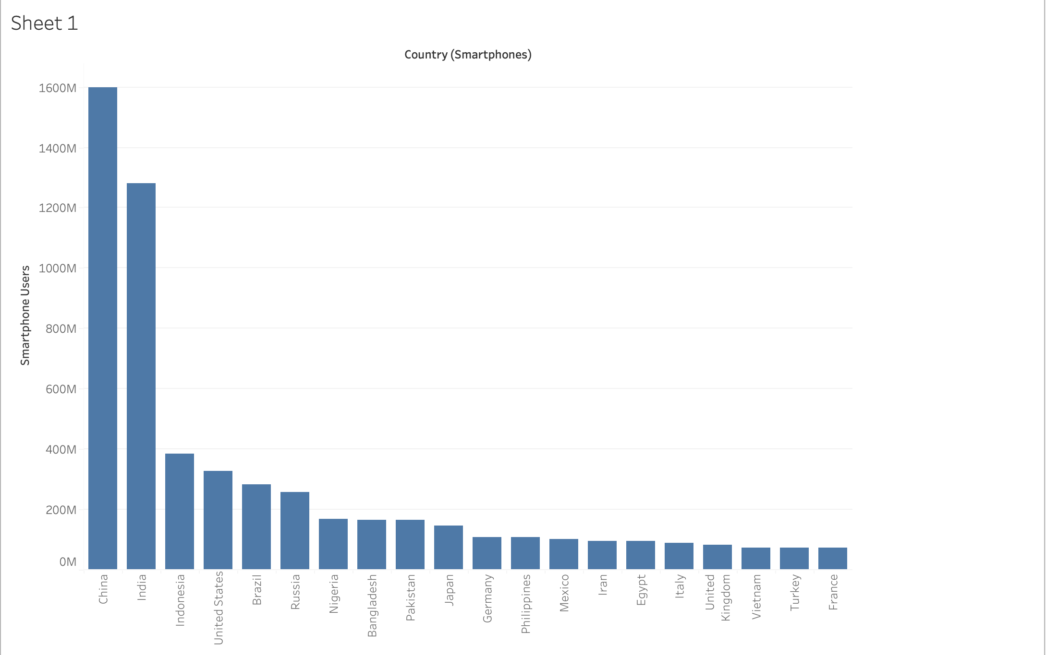
8. Next, I double-clicked on the title at the top of the chart and changed the chart heading to ‘Countries with the Highest Number of Smartphone Users’. I centred the title and clicked ‘OK’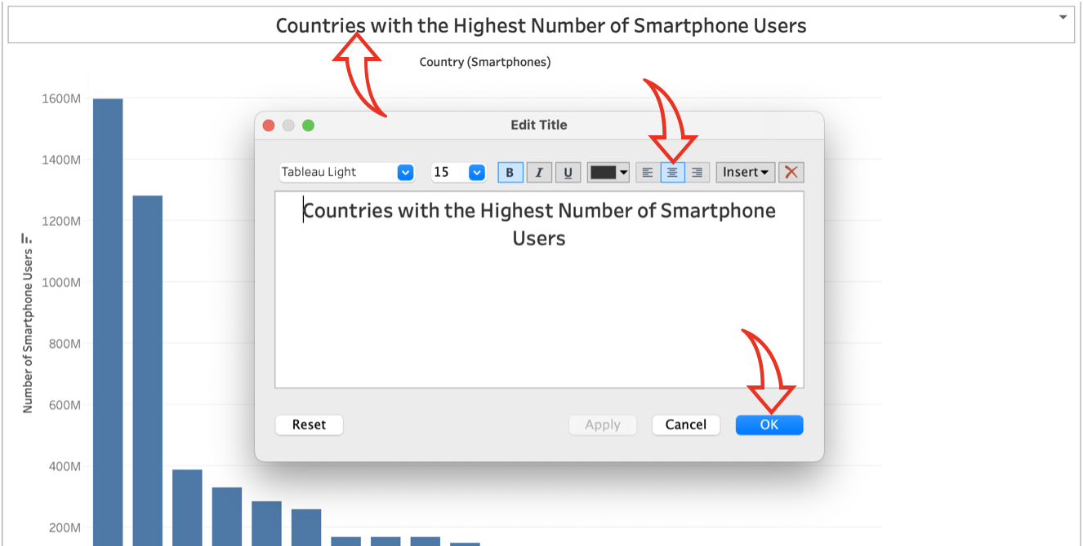
9. Right-clicking on the title, I opened up the Format Tab on the left and applied a colour border to my title: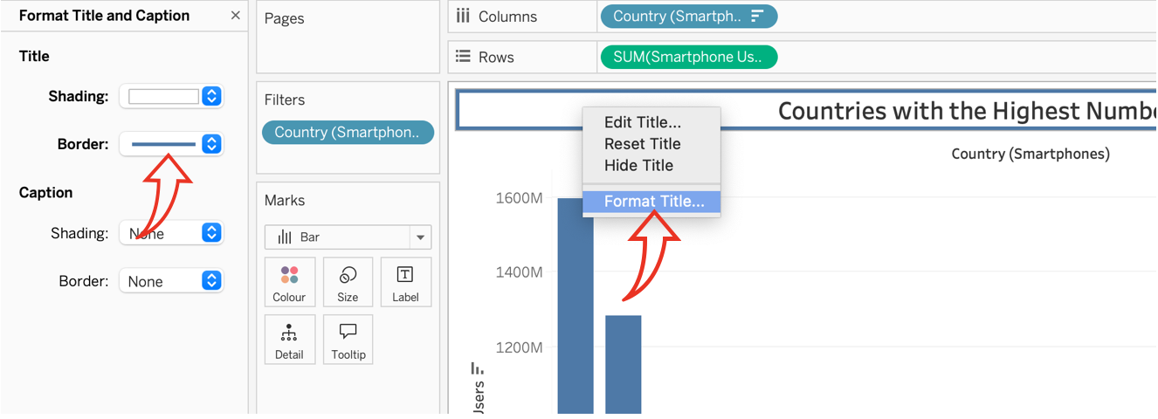
10. Right-clicking on the ‘Country (Smartphones)’ label under the title, I selected ‘Hide Field Labels for Columns’ to remove it from the graph: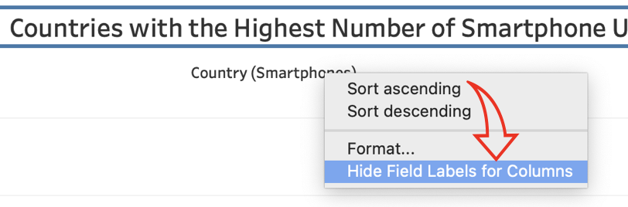
11. Right-clicking on the ‘Label’ box in the Marks section, I ticked the ‘Show mark labels’ tickbox to reveal the labels aligned above each bar, as follows: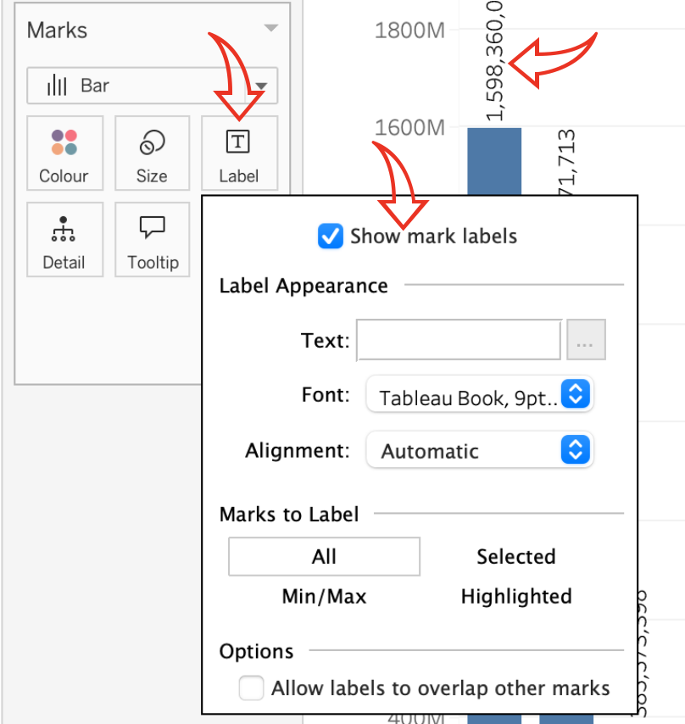
12. Finally, I renamed the sheet tab at the bottom by double-clicking on the ‘Sheet’ name and retyping it as ‘Smartphone Users by Country’: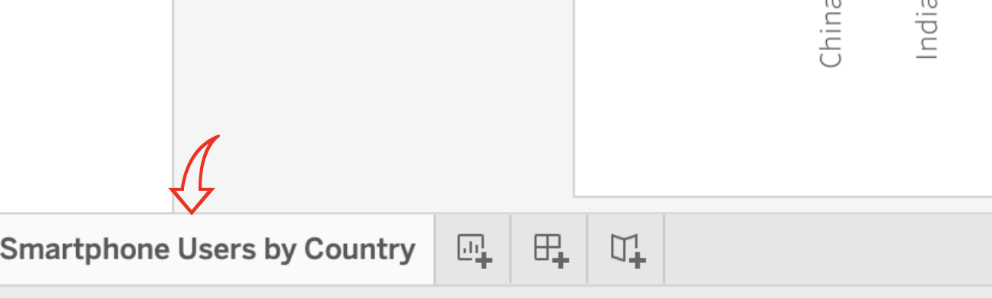
13. To make the chart more visually appealing, I dragged the ‘Country (Smartphones)’ data from the left onto the ‘Colour’ box in the ‘Marks’ section: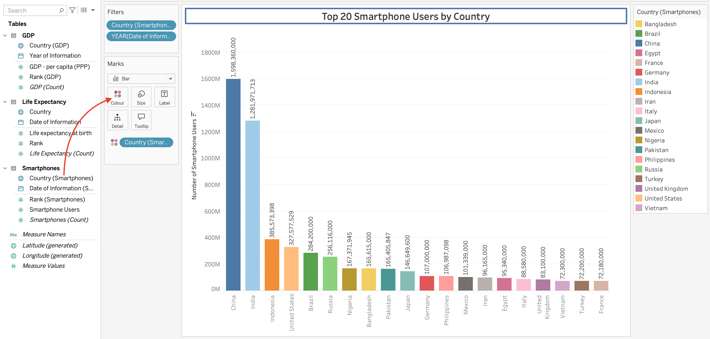
14. Clicking on the “Colour’ box, I selected ‘’Edit Colours’, then the ‘Colour Blind’ palette from the ‘Colour Palette’ dropdown. I clicked on ‘Assign Palette’ below the colours and clicked yes to the next window asking me if I wanted to assign the 10 colours to more than one item and clicked ok to complete this action: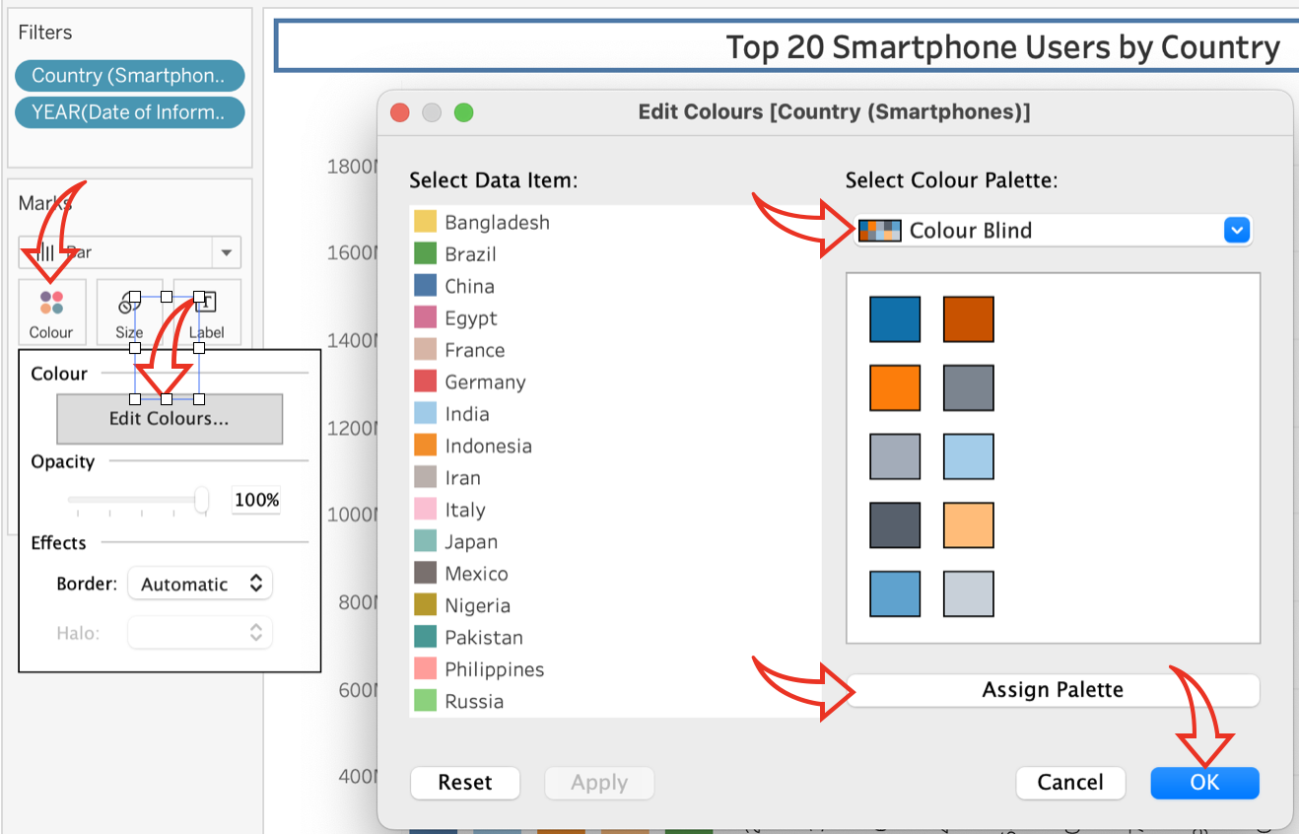
15. To ensure the labels were showing correctly, I dragged the ‘Smartphone User’ data from the left over the ‘Label’ box in the ‘Marks’ section and amended the measure to ‘Average’ by right-clicking on the new green pill that appeared in the ‘Marks’ box: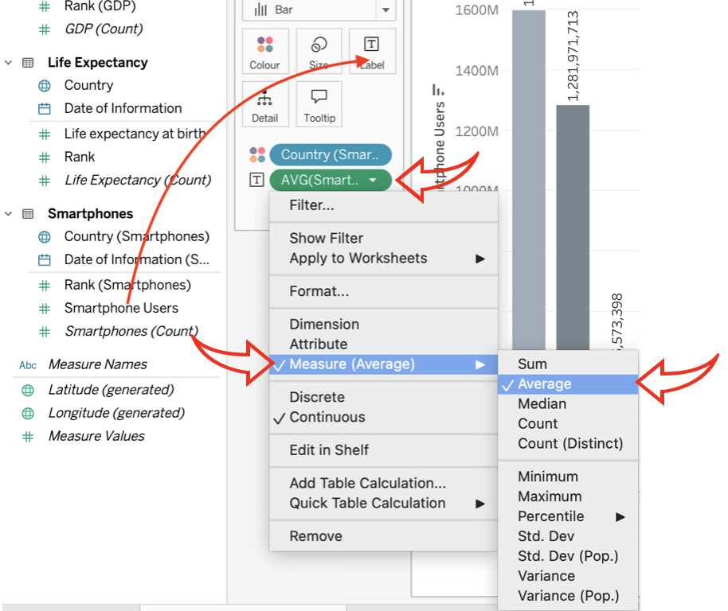
16. My chart now looks like this: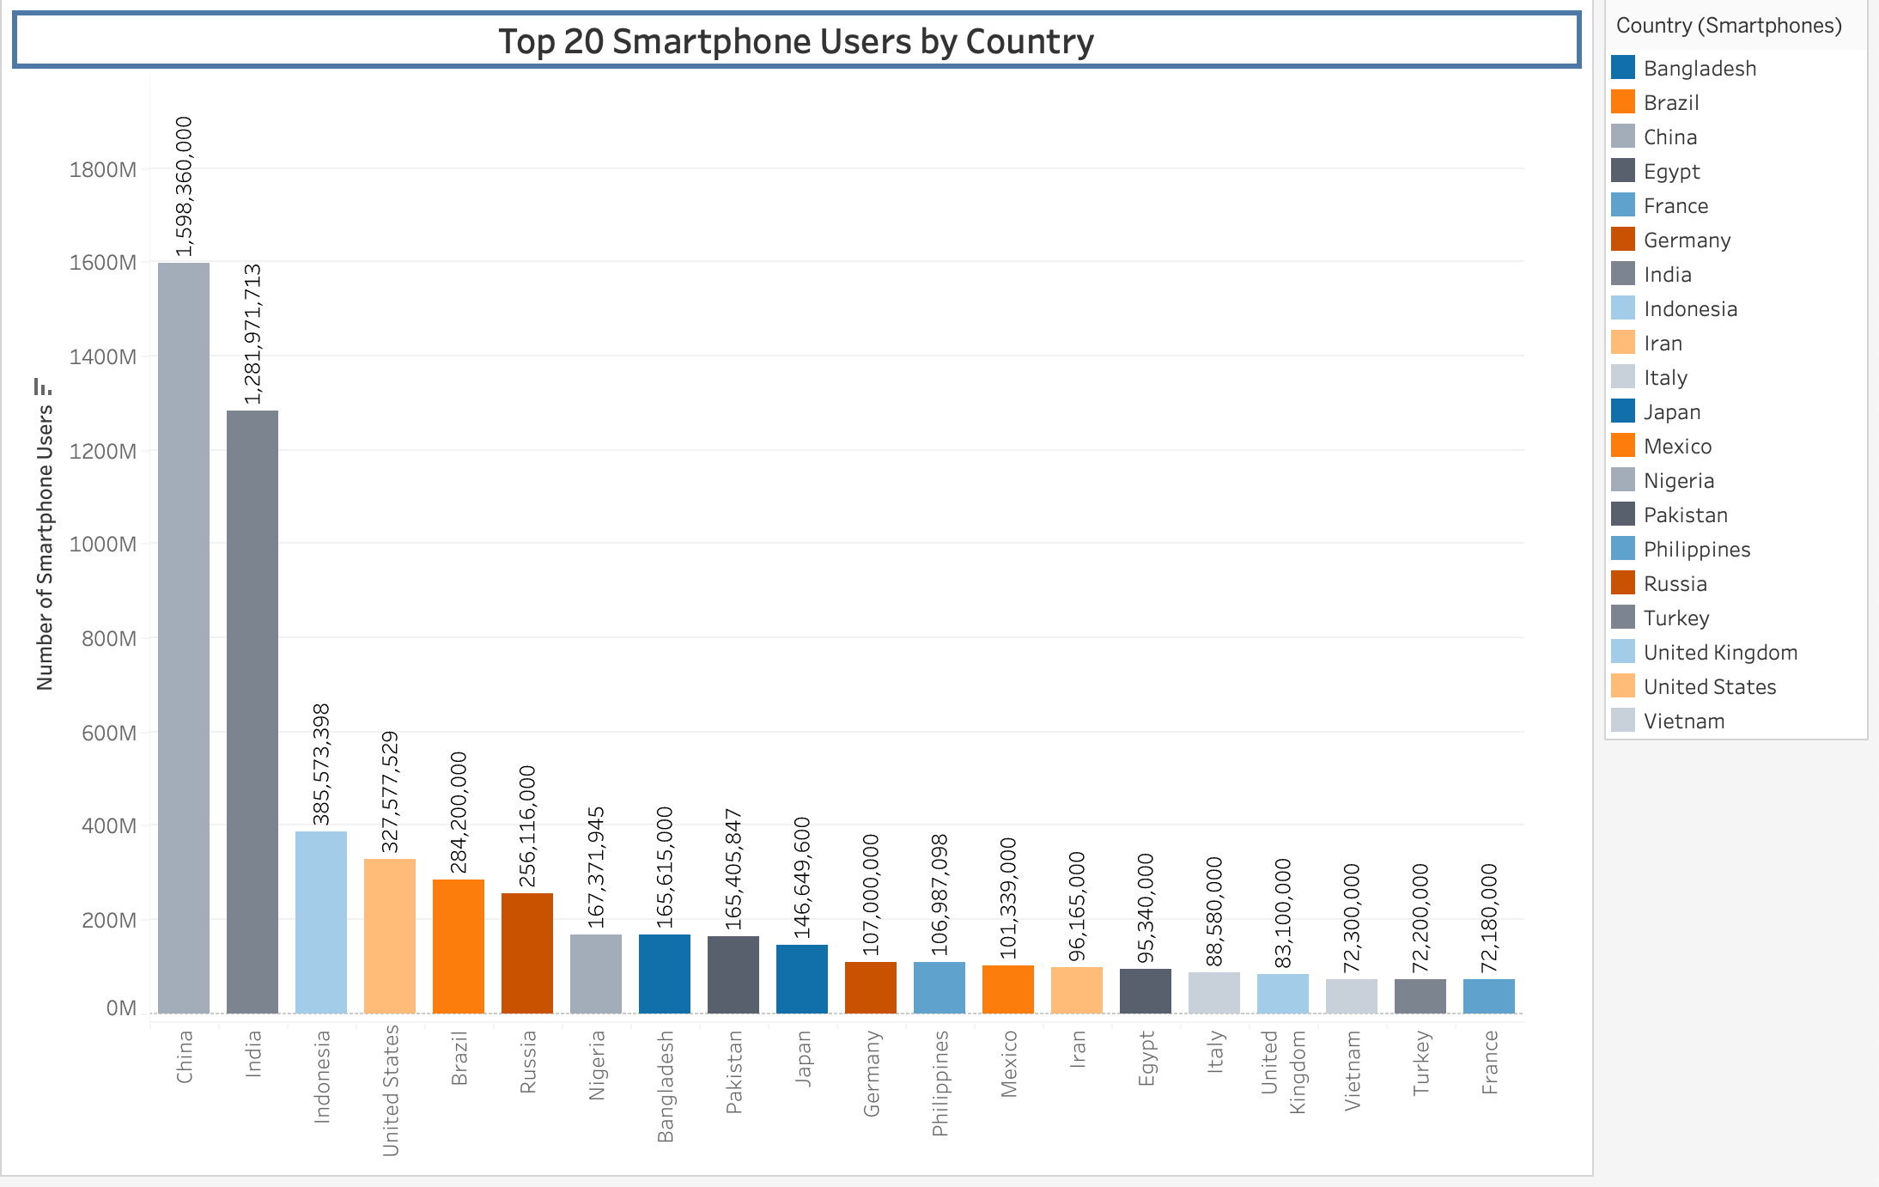
17. Now that I have my first visual, I need to make my second one. I clicked on the small tab next to by current sheet at the bottom to add a new sheet: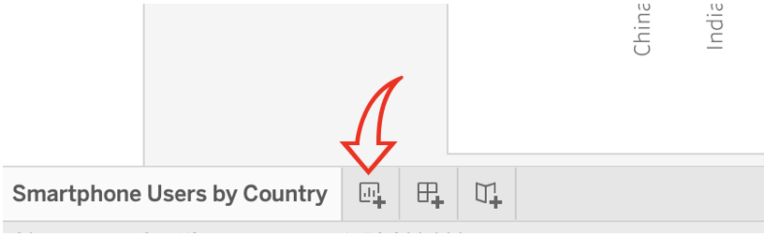
18. In this visual I want to show the relationship between Life expectancy and GDP per capita. First, I renamed the sheet to ‘Live Expectancy vs GDP per Capita’, as I did for the first sheet: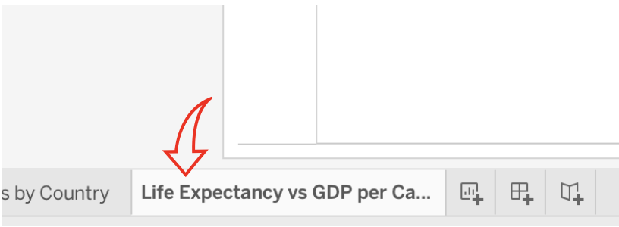
19. I added the ‘Life Expectancy’ data from the lefthand side to the ‘Rows’ field at the top of the sheet and changed it to show ‘Average’. I also moved the ‘Country’ data from the Life Expectancy section on the left to the ‘Column’ field at the top, in the same way as I did for the first visual. Finally, I filtered it to the ‘Top 20’ countries and sorted it in descending order according to the ‘Life Expectancy’ field, as follows: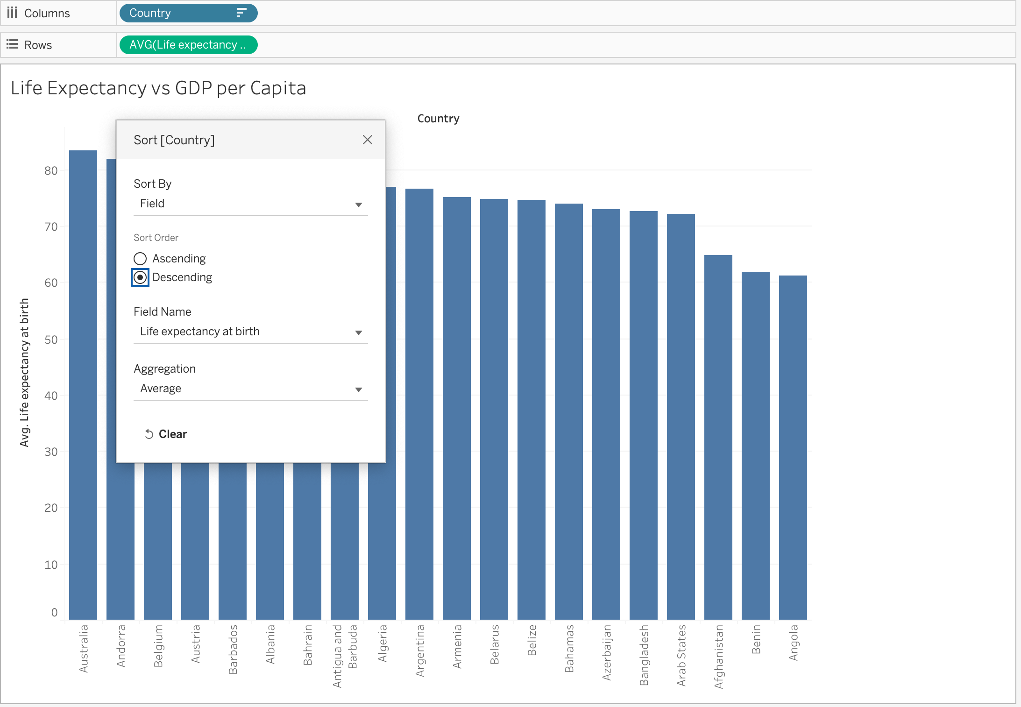
20. To create a dual axis chart, I dragged the ‘GDP per Capita’ data to the righthand side of the graph, until a dotted line appeared and release it. The chart changed as follows: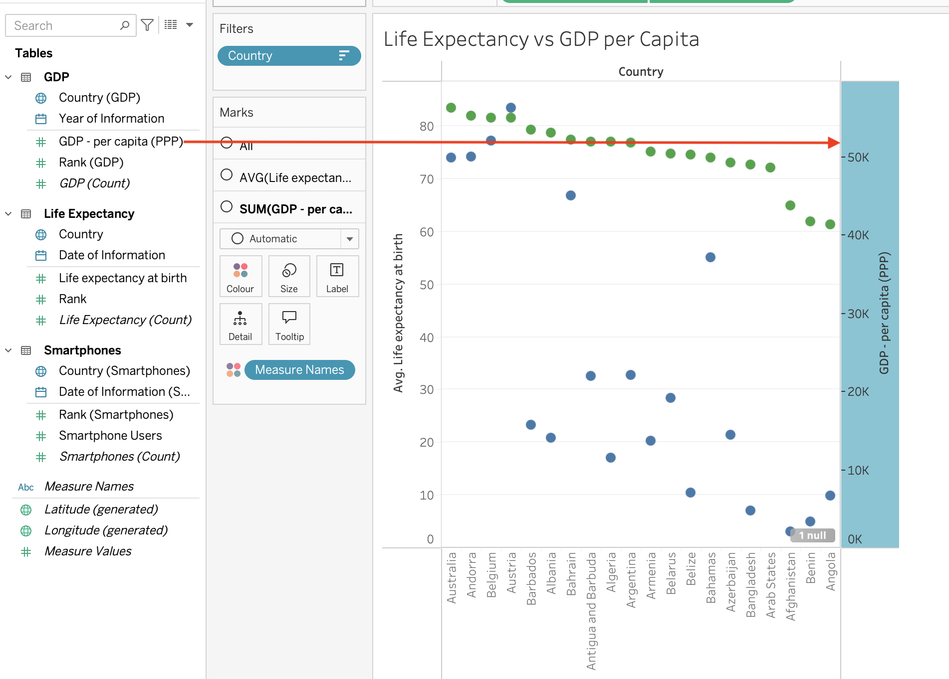
21. Right-clicking on the newly created axis on the right, I selected ‘’Synchronise Axis’ to synchronise it with the left axis for ‘Life Expectancy’, then de-selected ‘Show Header’ to hide the axis: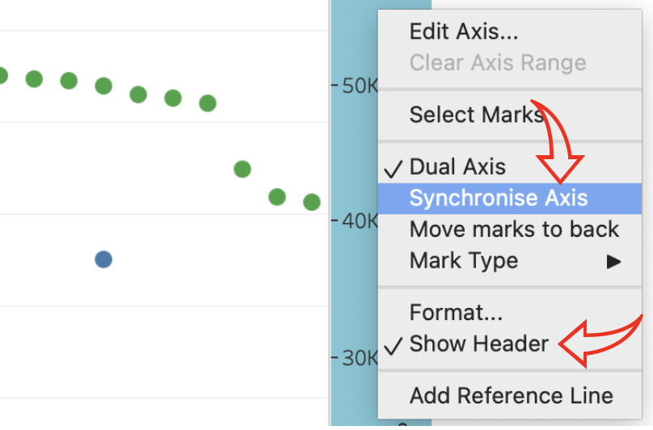
22. My chart now looked as follows. However, I noticed that there was an issue: the green ‘Life Expectancy’ data appeared as a straight line at the bottom of the chart; and there was at least 1 null value in the data: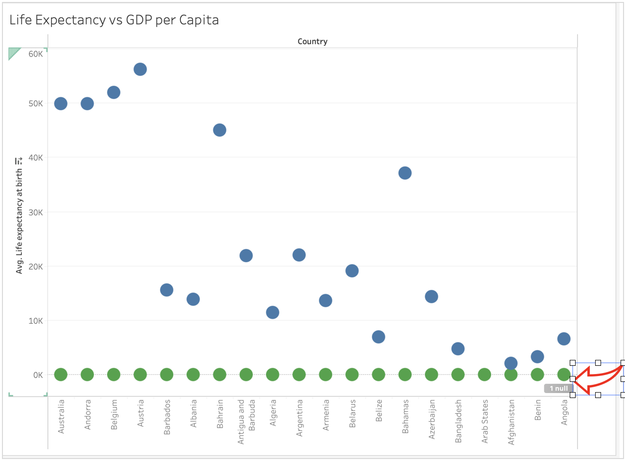
23. So I went back a step by clicking on the back arrow at the top of the window to reveal the righthand axis again and right-clicked to bring up the floating menu. I deselected ‘Synchronise Axis’. Now the blue ‘GDP per Capita’ data was showing a bit better in relation to the green ‘Life Expectancy’ data.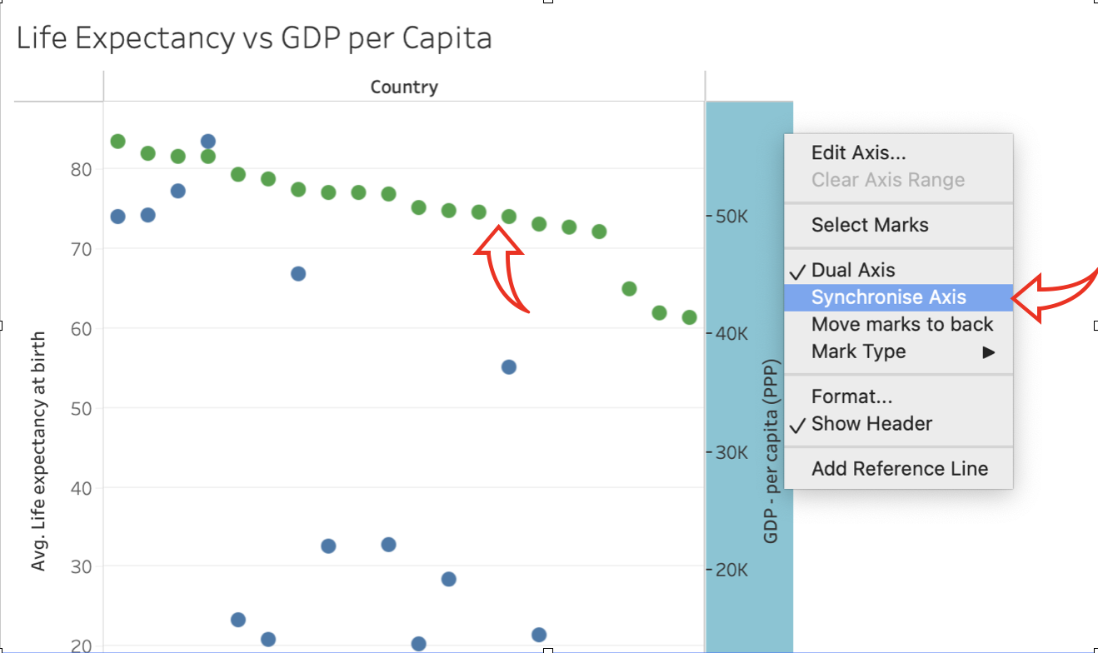
24. Clicking on the grey ‘1 null’ box at the bottom right corner of the chart, I selected the ‘Filter Data’ box in the ‘Special Values’ window that opened up to exclude the null value from the chart: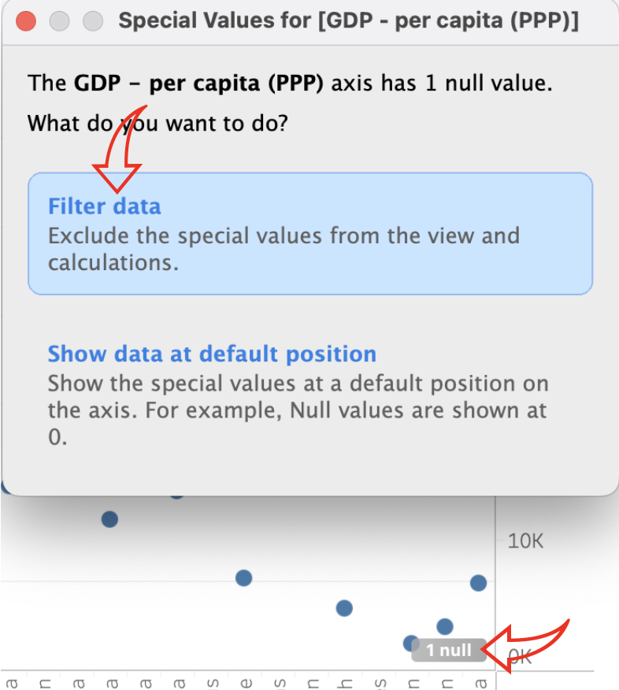
25. To change the appearance of my chart, I clicked on ‘Sum(GDP - per capita)’ in the ‘Marks’ section to the left of the chart, then on the dropdown just below it and selected ‘Shape’: The blue dots changed to a shaded peak and trough shape: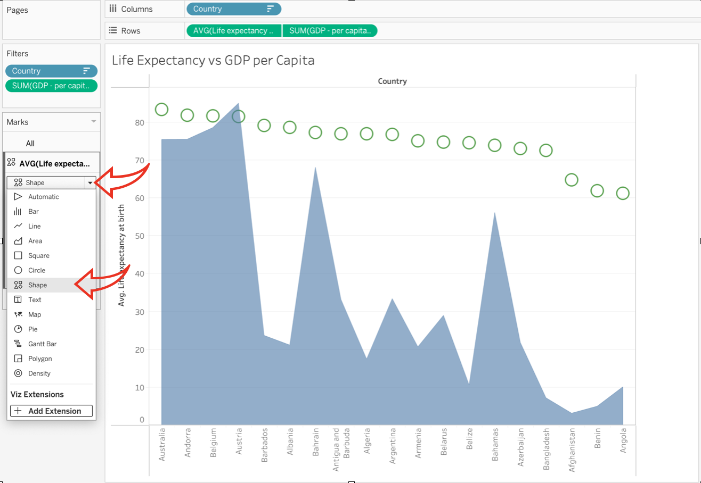
26. I did the same for the Life Expectancy data, except I change it to a line graph. Now my chart looked like this: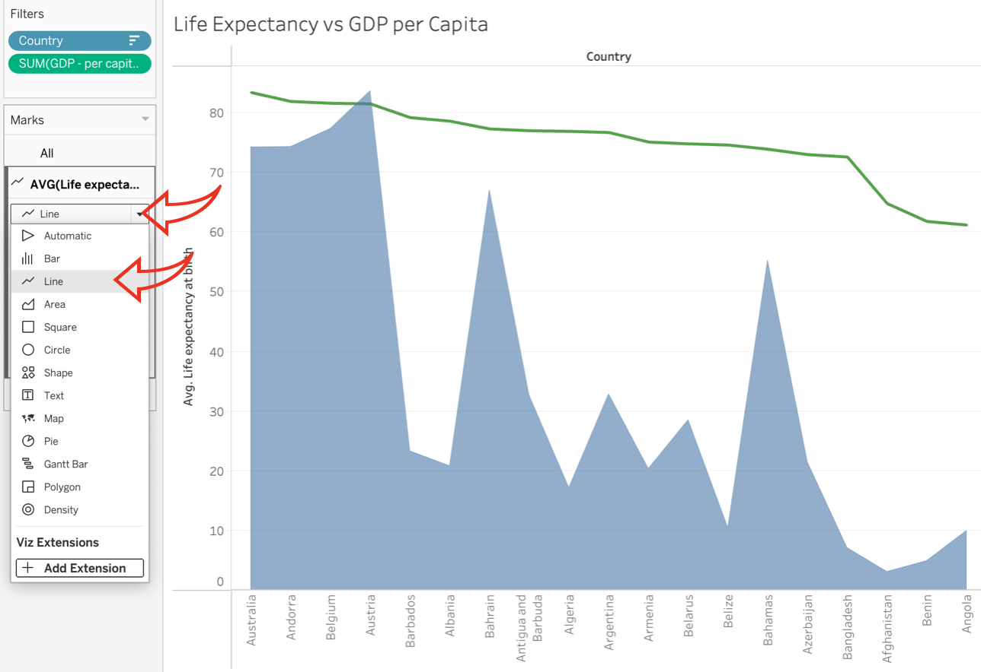
27. According to Shaffer (2016), blue and red work well together for most colour vision deficiencies. I therefore chose a darker heavier red for the line to make it easily seen and a lighter blue for the shaded area so that it is also well-contrasted against the red line.
28. To do this, I went to the top righthand side of my sheet and clicked on the down arrow in the ‘Measure Names’ legend box to edit the colours. In the ‘Edit Colours’ window, I selected the ‘Colour Blind’ palette and assigned the darker red to the ‘Life Expectancy’ data and the lighter blue to the GDP data: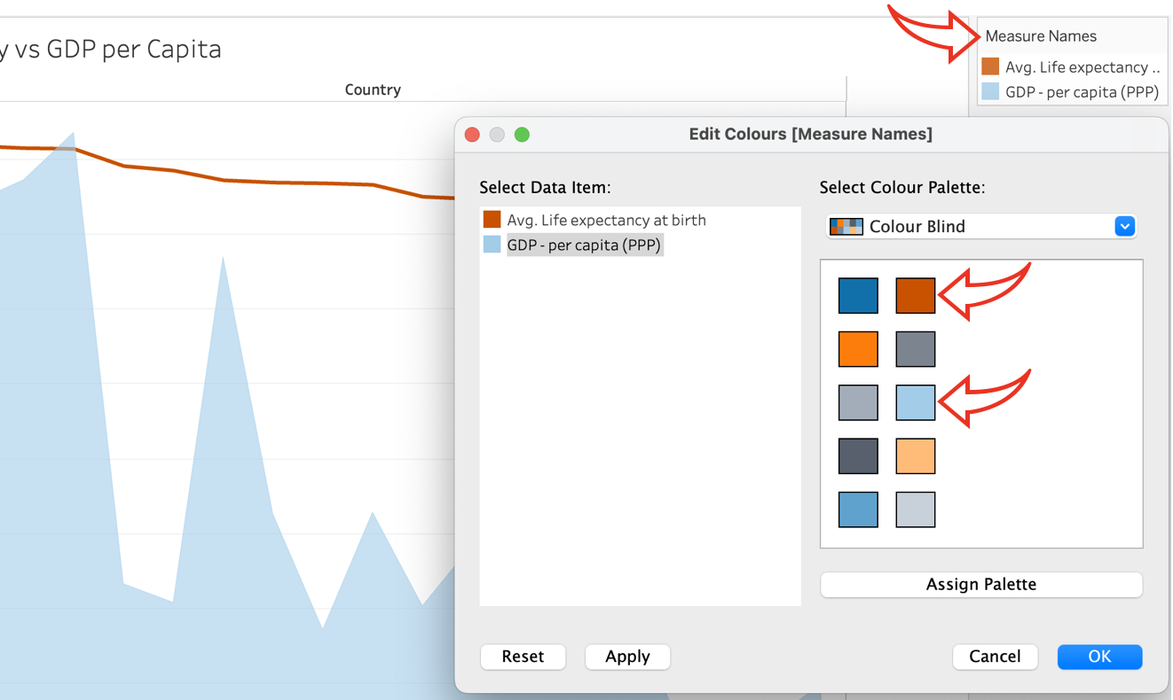
29. Going back to the ‘Marks’ panel on the left, I selected the ‘Life Expectancy’ dropdown and clicked on ‘Labels’. In the window that appeared, I ticked the box next to ‘Show mark labels’ and set the alignment: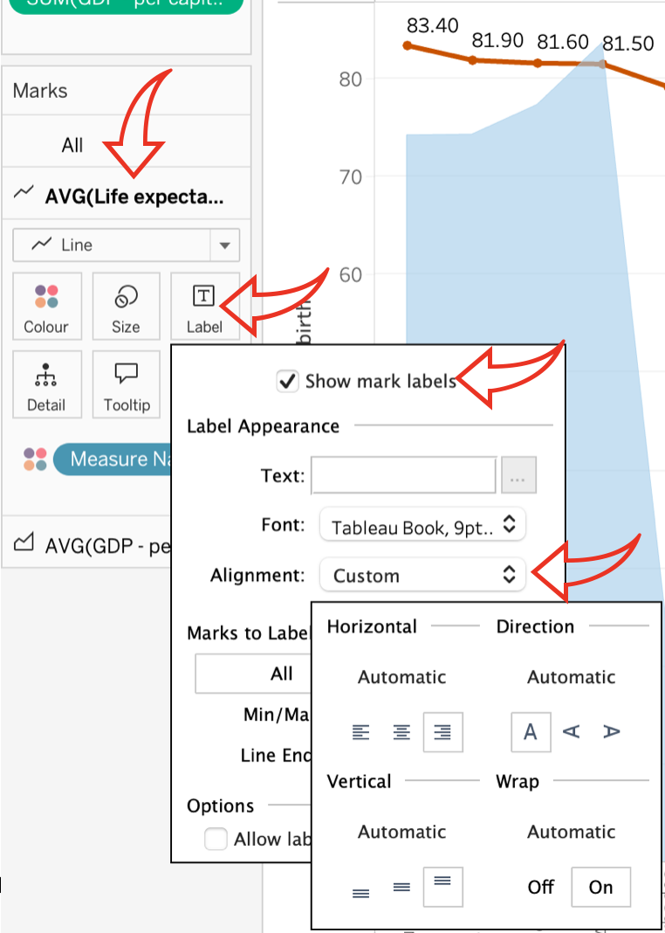
30. Next, I changed the font and look of the labels in the ‘Font’ dropdown. I made the text bold to make it easy to read and matched the colour to the line to distinguish it from the labels I will do for the ‘GDP’ graph: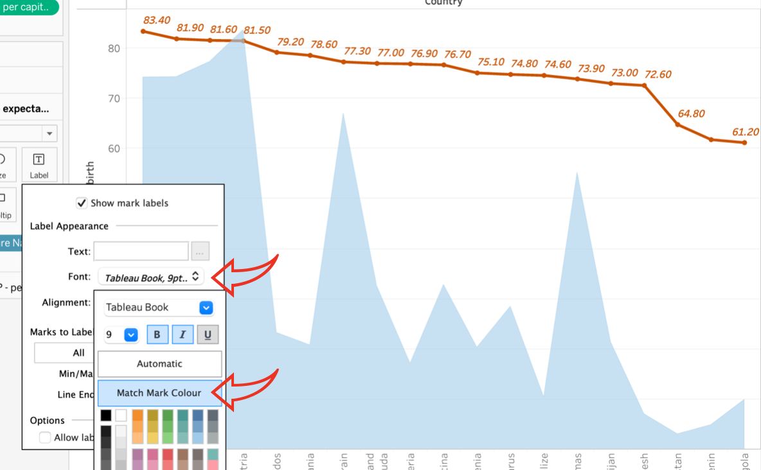
31. I did the same for the GDP shaded graph, but aligning the text vertical and positioning where it didn’t interfere with the Life Expectancy line too much. I also made the text bold but assigned a dark blue colour to further distinguish it and to link it more closely to the shaded graph. I then clicked in the ‘Colour’ box and assigned a border to the shaded area.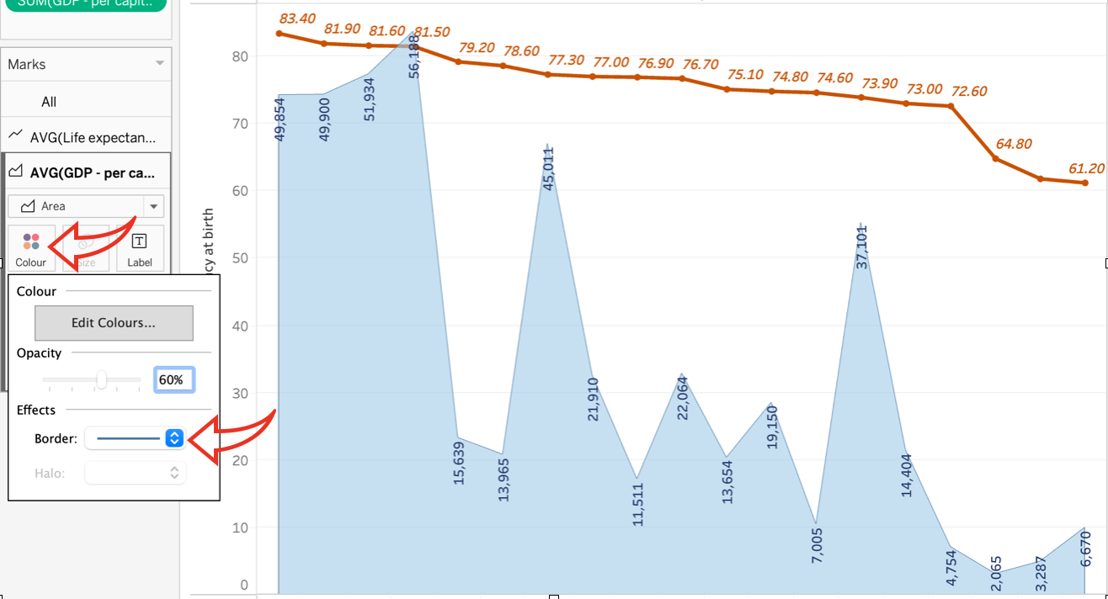
32. I dragged the ‘Life Expectancy’ data over the Tooltip box for the ‘GDP’ chart and the ‘GDP per Capita’ data over the Tooltip for the ‘Life Expectancy’ chart, so that the floating Tooltip window shows all the data for any particular point in the chart that I hover my cursor over: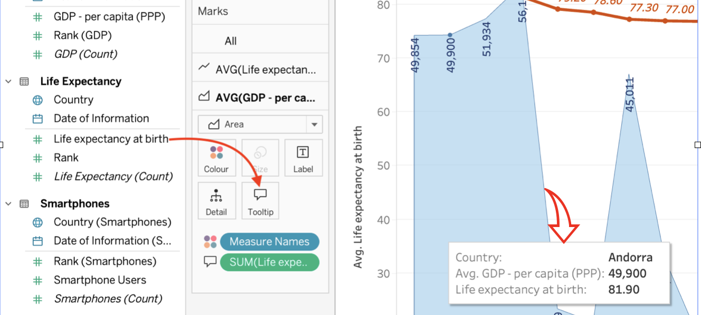
33. I reformatted the chart heading to match the’Smartphone Users’ sheet, hid the field label for ‘Columns’. I re-formatted the ‘Rows’ axis, amending the title name, excluding ‘zero’ and making the axis range uniform.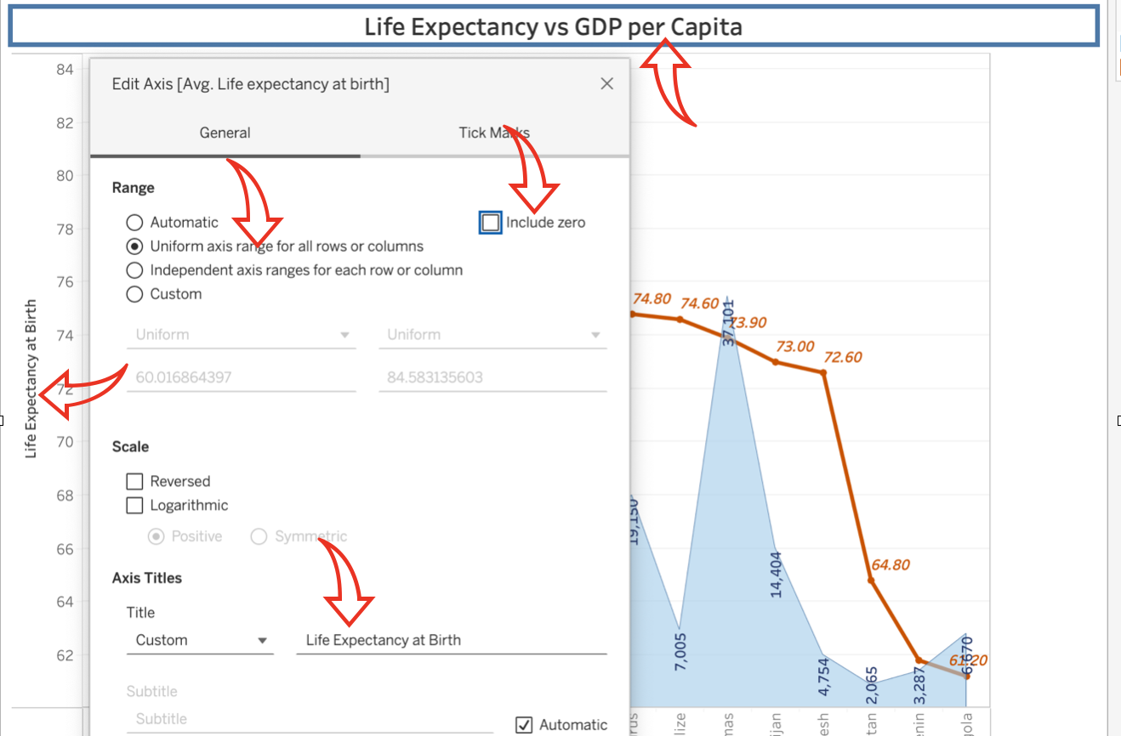
34. This dramatically altered charts, making it the flow even clearer as follows: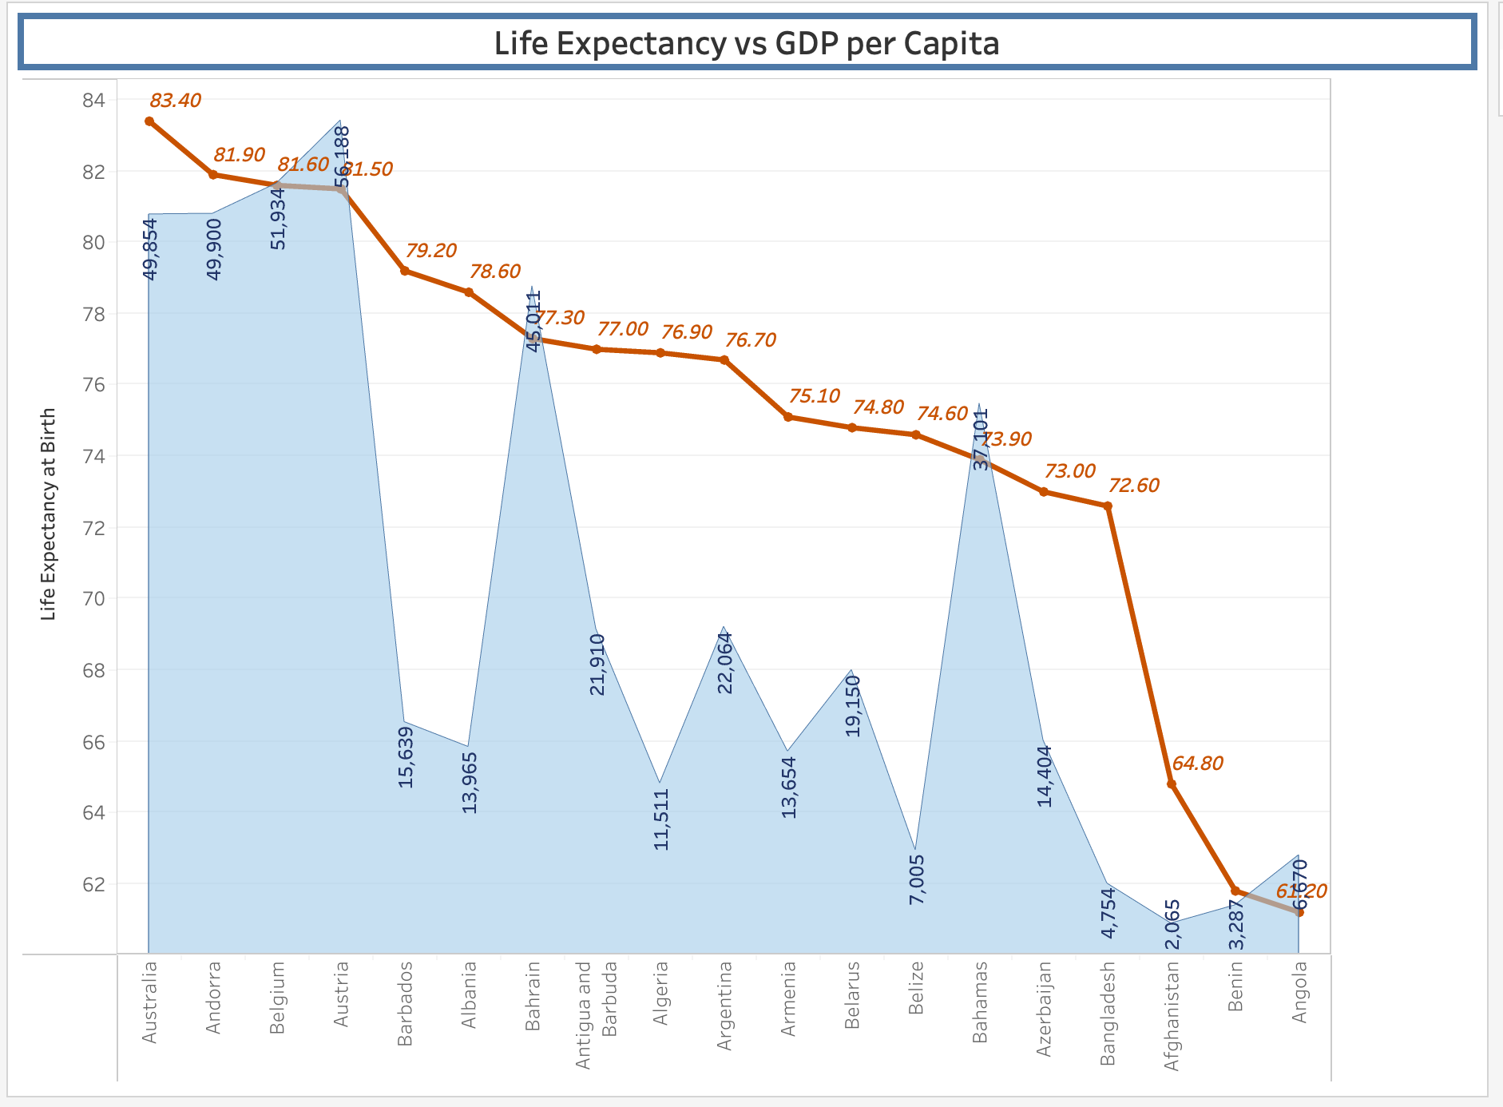
35. We can see from this chart that generally speaking, the higher the GDP per capita, the higher the Life Expectancy is from birth, although this is not necessarily the case for all countries.
36. Now for the third visual. In this one I want to show the relationship between Smartphone Users and GDP per Capita. I created and renamed a third sheet as ‘Smartphone Users vs GDP per Capita’ and pulled the relevant data from the lefthand side to the column and rows fields: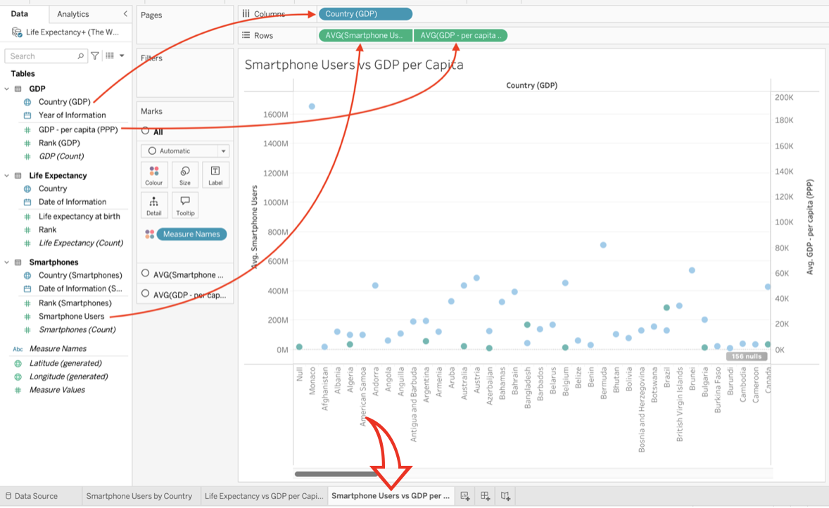
37. I filtered out the null values and applied a Top 20 filter to the Countries (GDP) to show only the top 20 countries: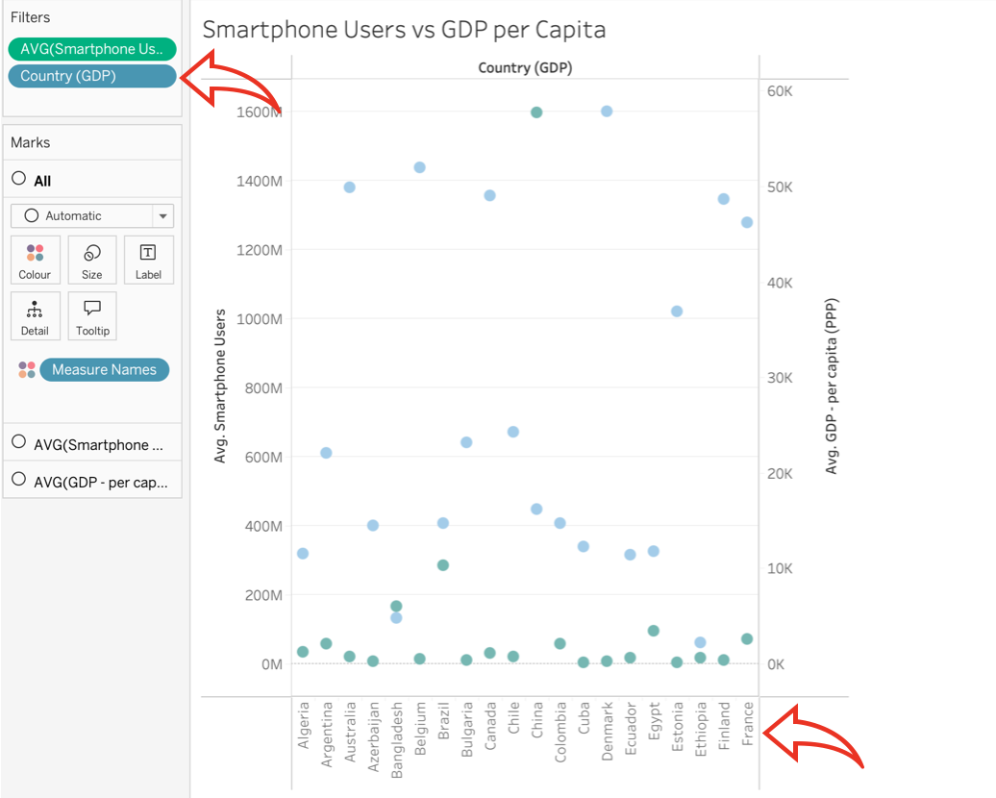
38. In the ‘Show Me’ dropdown to the right, I selected a Treemap graph: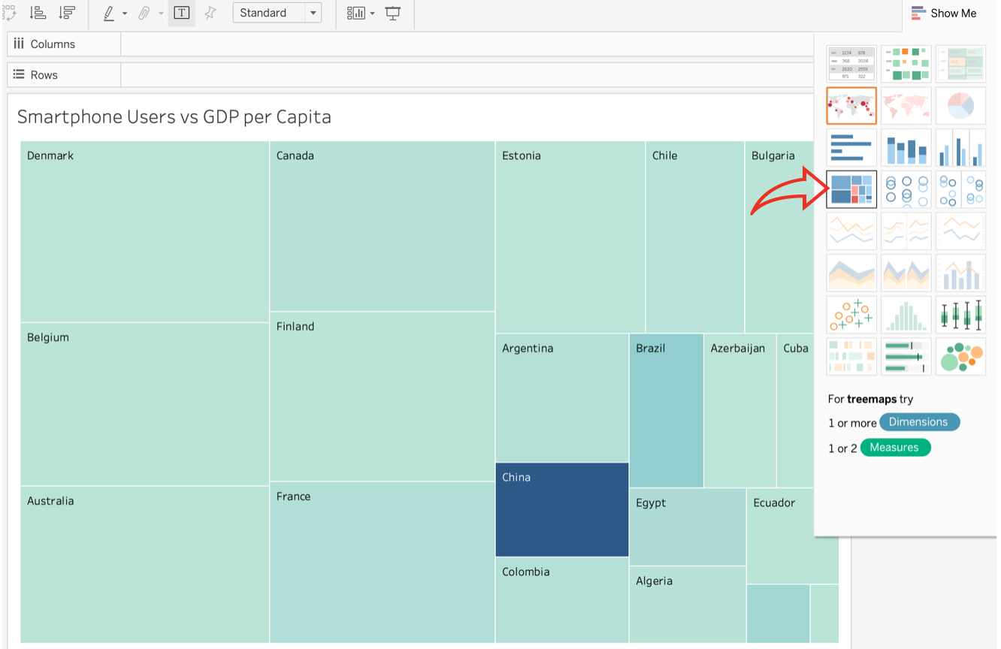
39. I formatted the colour and style of the Treemap by clicking on the ‘Legend’ box at the top right and selected the Blue-Red colour option for good contrast, then formatted the ‘Label’ and ‘Tooltip’ boxes in the Marks section, so that the Countries showed in bold, with the number of Smartphone users and GDP per Capita figures clearly marked: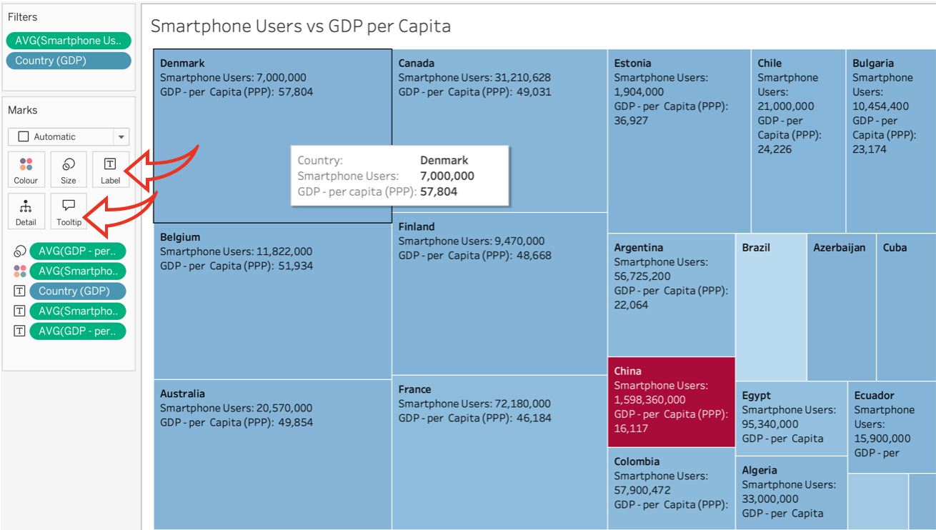
40. Interestingly, China stands out as an anomaly. While it doesn’t have the highest GDP per capita, it does have the highest number of smartphone users in the world. Of course that could be down to them having had the highest population in the world, with 1.41 billion people as of 1st November 2020 (Cheng 2021).
41. Finally, I formatted the chart title in the same way as the first two to match them: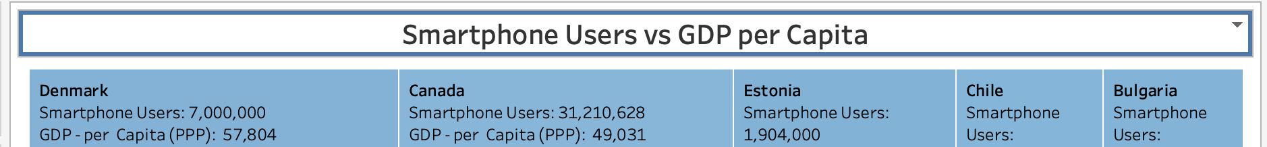
42. For the next visual, I duplicated the ‘Smartphone Users vs GDP per Capita’ sheet as a Crosstab sheet, by right-clicking on the sheet tab at the bottom and selecting the relevant action: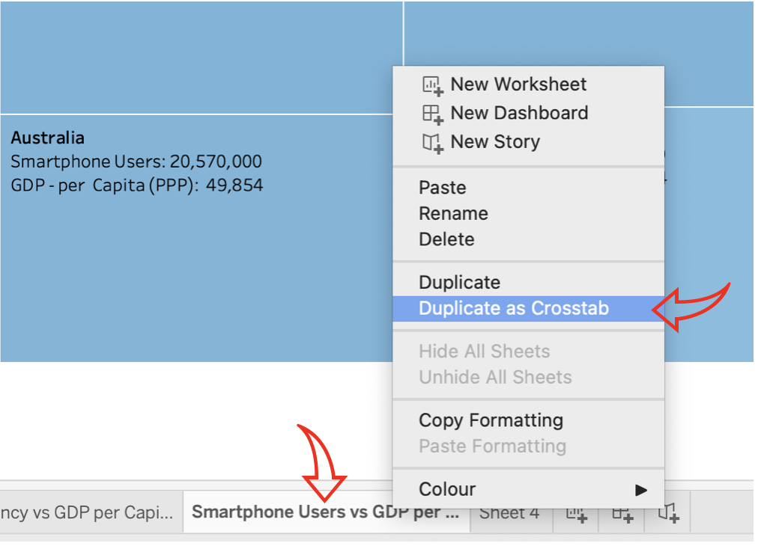
43. Going to the ‘Show Me’ tab at the top-right, I selected the ‘Symbol Map’: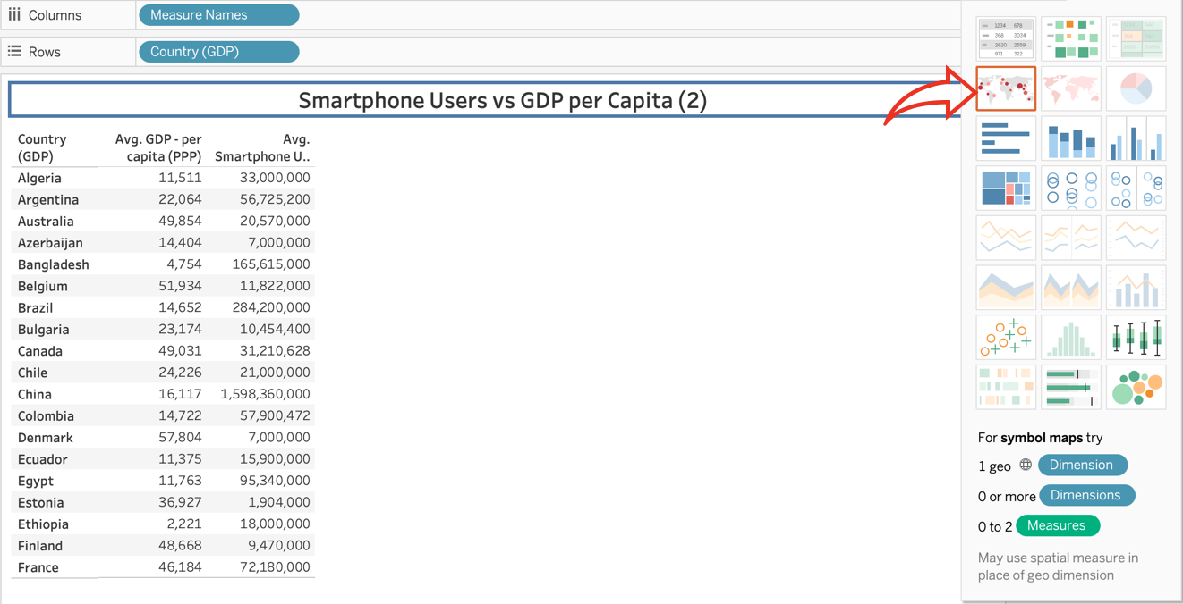
44. I amended the title to differentiate from the previous sheet. My visual now looked like this: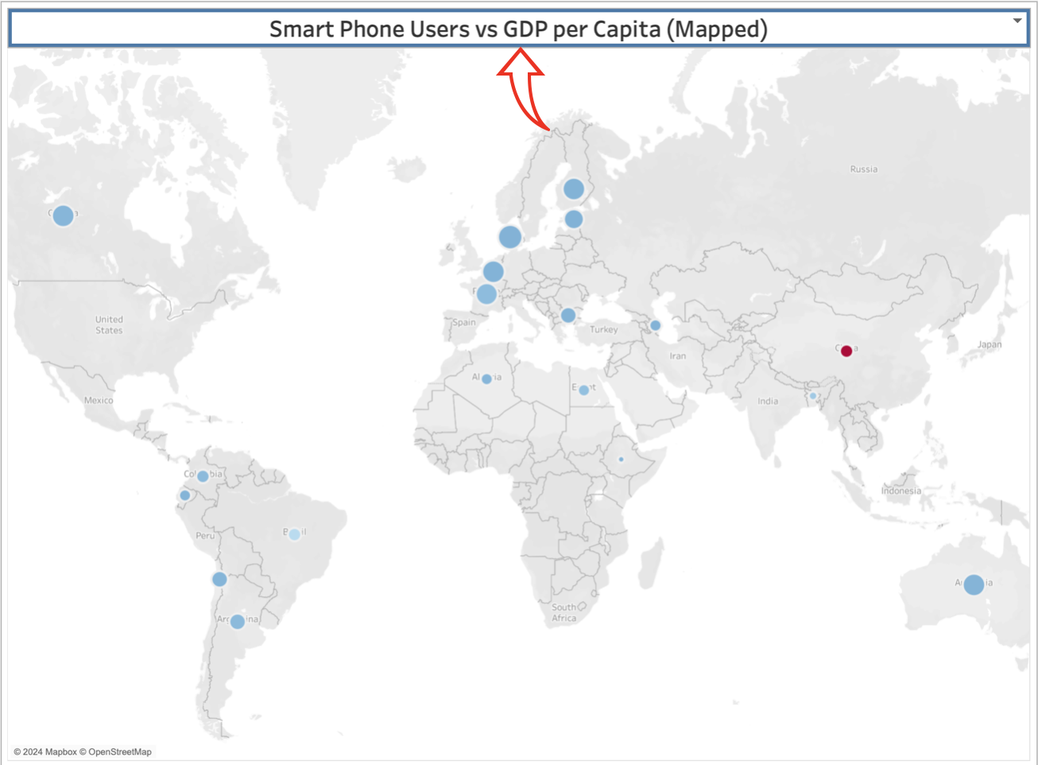
45. To make the visual clearer, I made the circles larger and added a black border with a white halo behind via the ‘Size’ and ‘Colour’ boxes in the ‘Marks’ section on the left. I also added the country names as labels under each circle via the ‘Label’ box.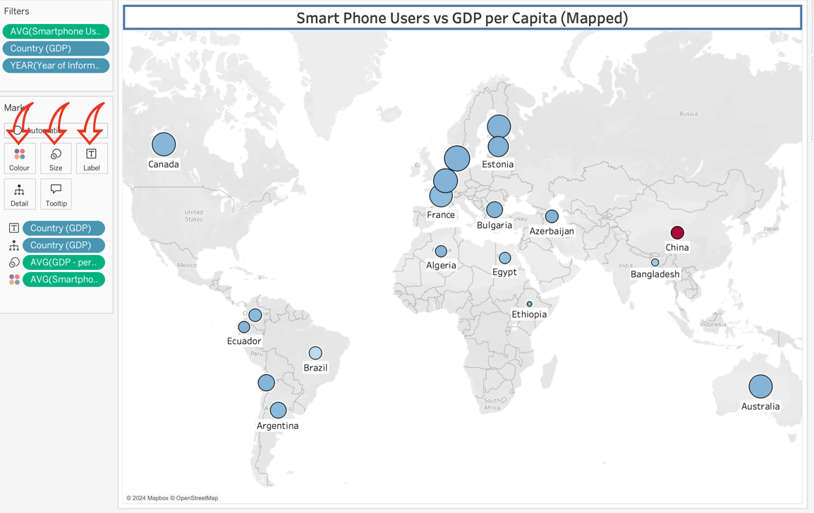
46. We can now see that the countries with the highest number of Smartphone Users vs the countries with the highest GDP per capita are concentrated in the northern hemisphere and to the ‘Western’ nations, such as Europe and Canada, with Australia being the only such nation in the southern hemisphere. China still shows as the anomaly as with the treetop chart.
47. I also did the same with the ‘Life Expectancy vs GDP per capita' chart and created the following Crosstab map of the data: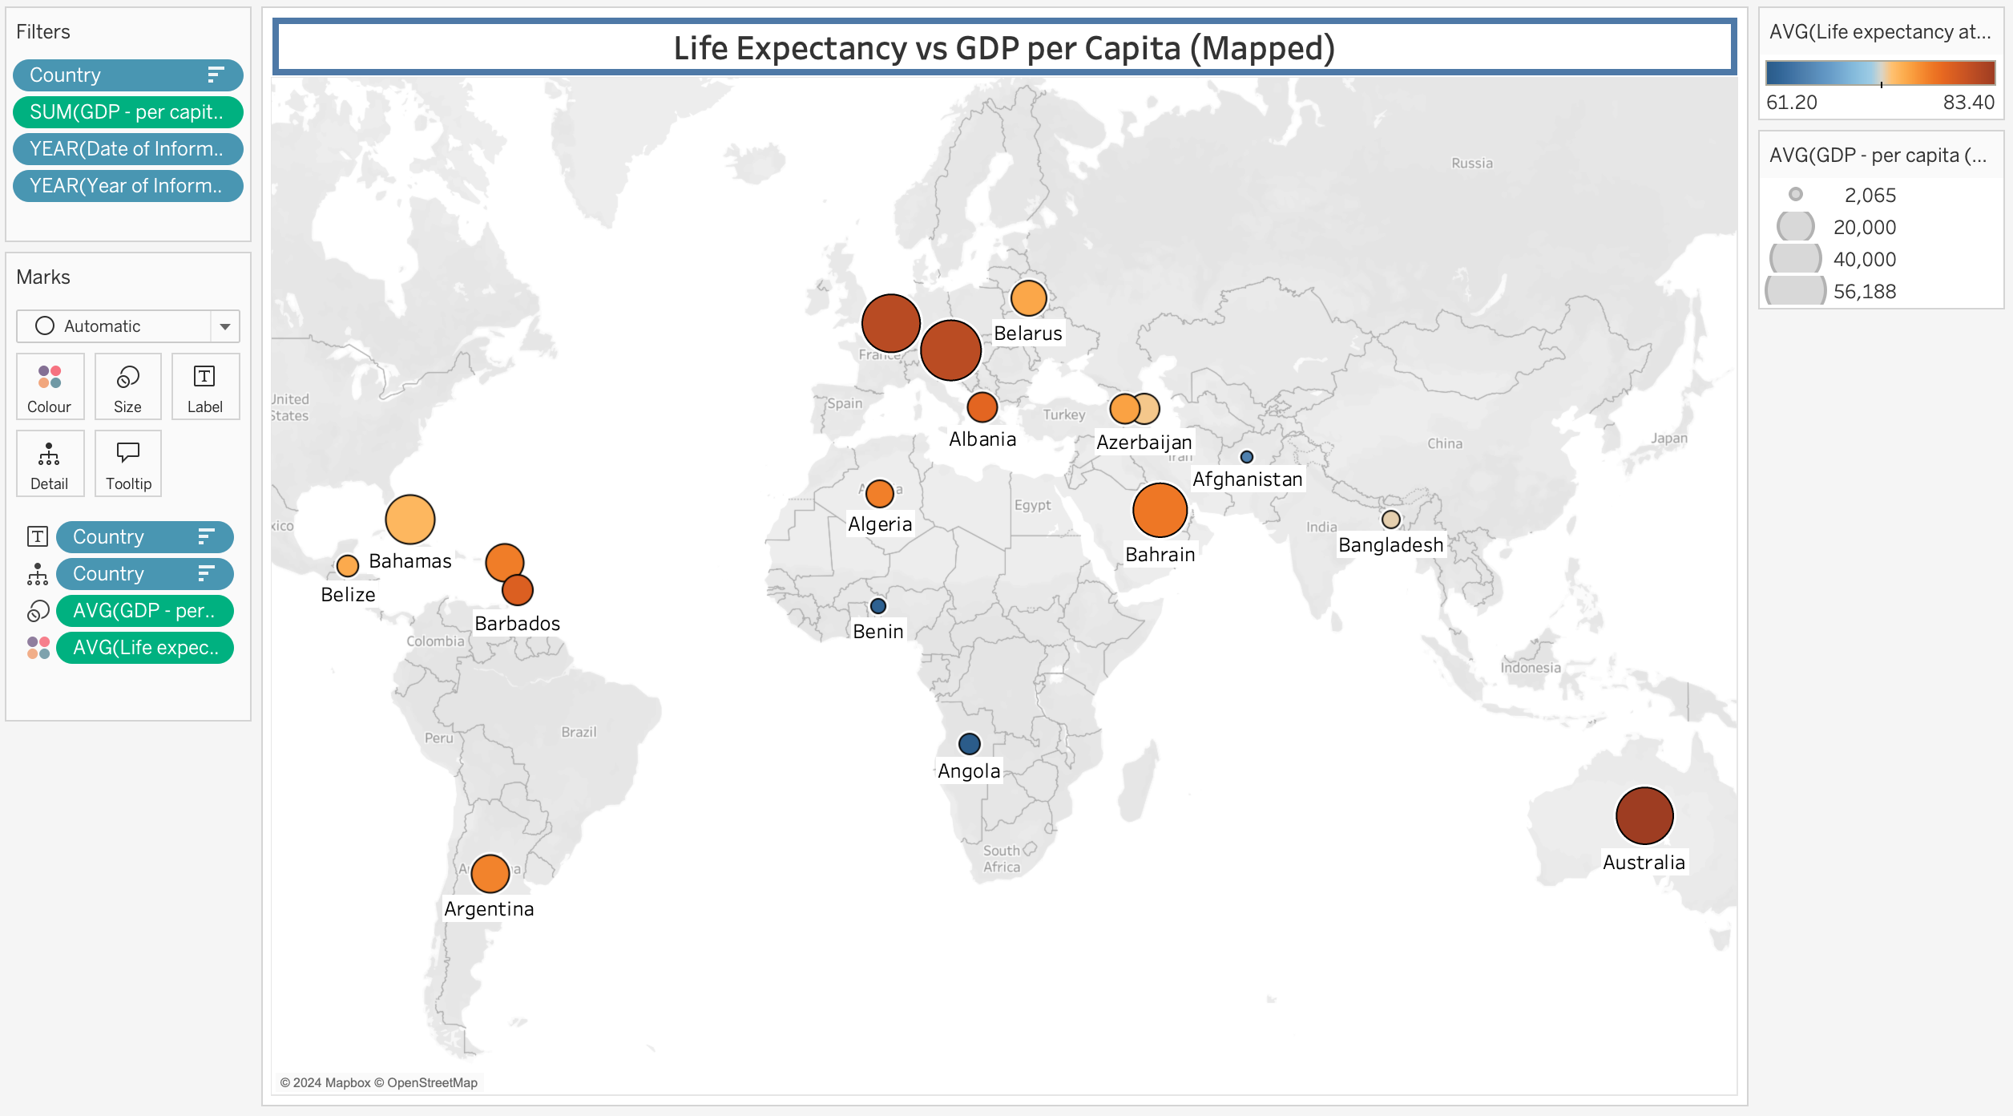
48. As a final visual, I added a 6th sheet and re-named it ‘Life Expectancy By Country’. After filtering it to the top 20 countries and sorting in descending order, I noticed that there was not much variation in the age data between them. So a column chart did not work so well. After exploring several options, I settled instead on representing the chart using circles instead of bars. I added a gridline in the background and an average line. I applied the ‘Colour-Blind’ palette to the chart: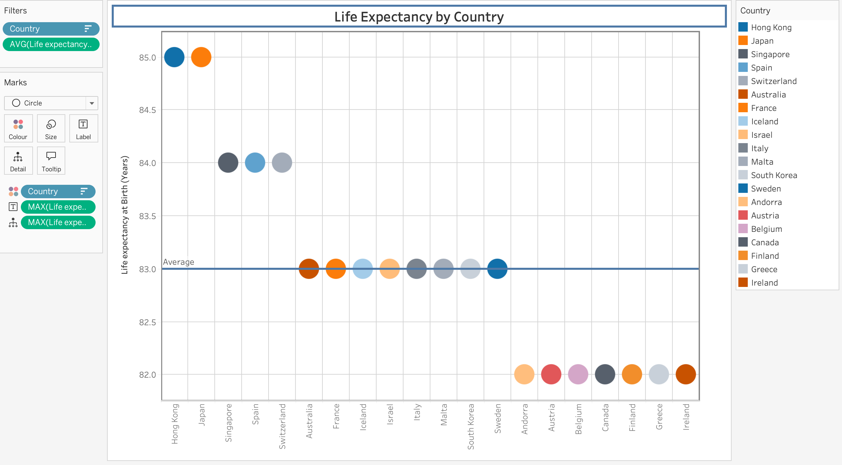

## Step 4 - Building the Dashboards:

1. Now that I had six visuals, three for Life Expectancy and three for Smartphone Users, I can now create some dashboards.
2. To create the first dashboard, I went to the ‘Dashboard’ Menu at the top and clicked on ‘New Dashboard’: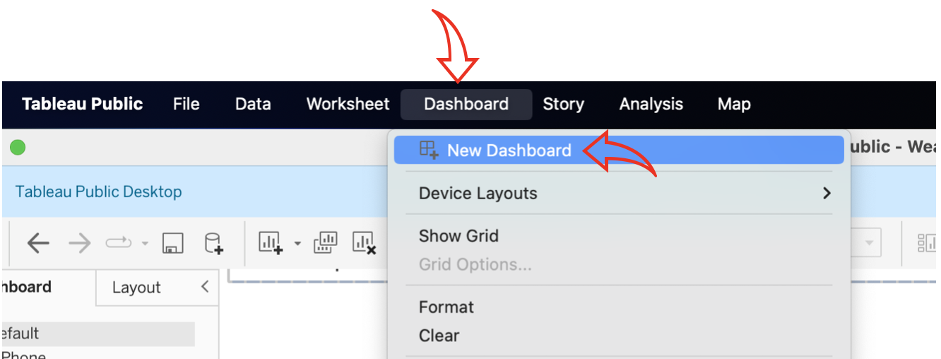
3. I could also have created a new dashboard page by clicking on the ‘Dashboard’ icon at the bottom of the pane and renamed the new tab as ‘Life Expectancy in Top 20 Nations’: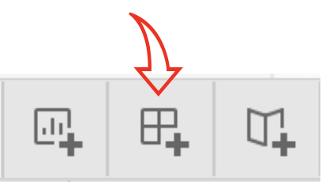
4. To add the first visual to the dashboard, I dragged the ‘Map of Life Expectancy vs GDP’ visual from the lefthand side: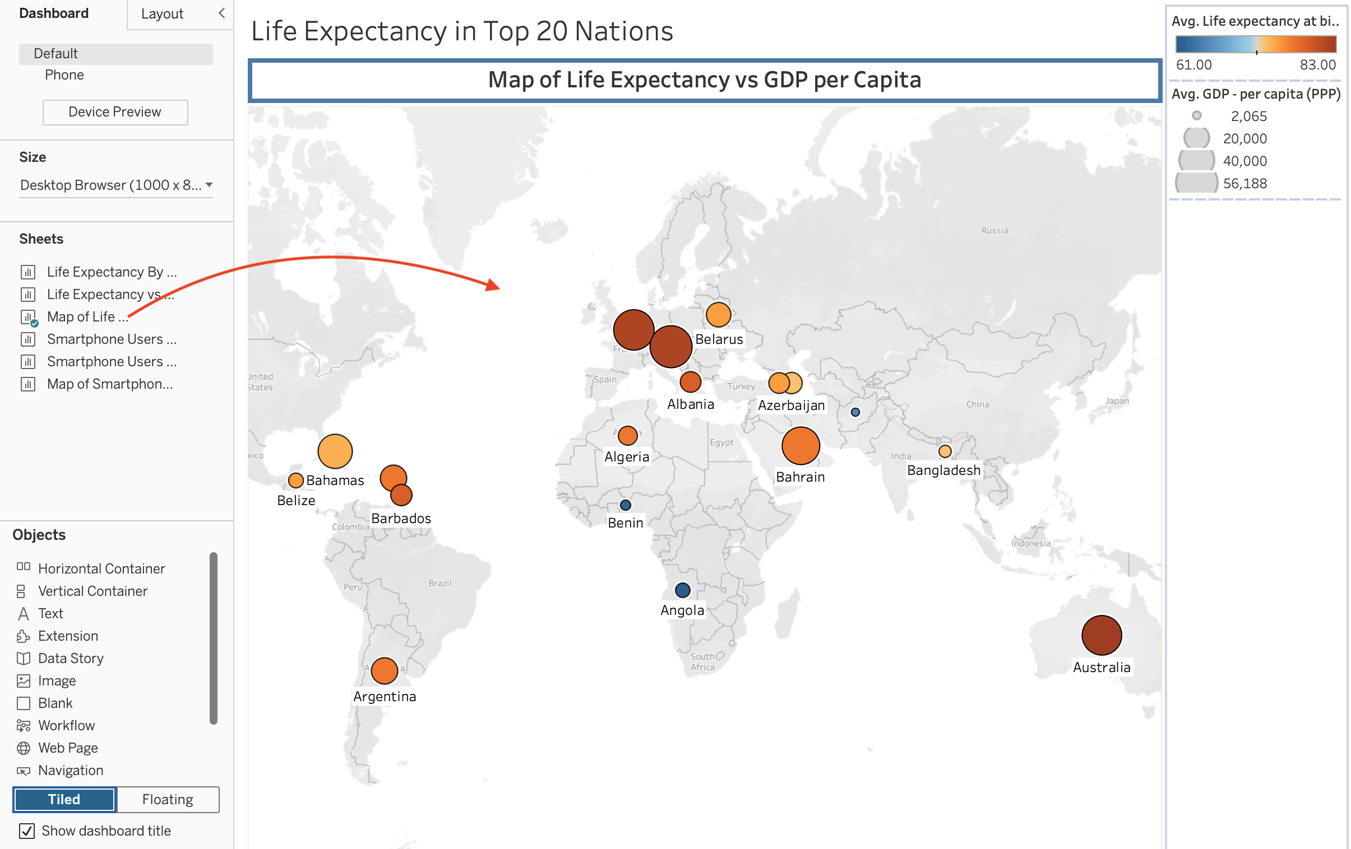
5. To make the legends at the top right floating legends, I clicked on the down arrow to the right of the first legend box and selected ‘Floating’ from the dropdown menu. I did the same for both legends: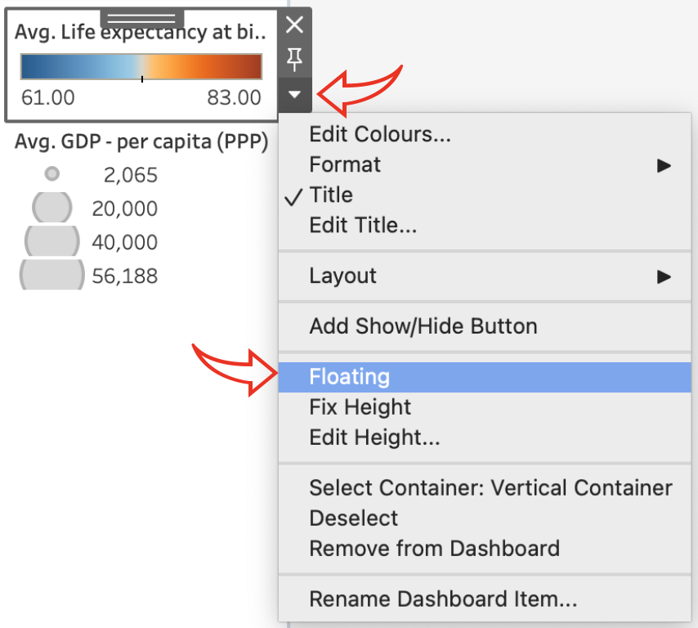
6. I moved the two legend boxes by grabbing the dark grey ‘handle’ at the top of the boxes and positioned them in a space on the map that did not have any data showing: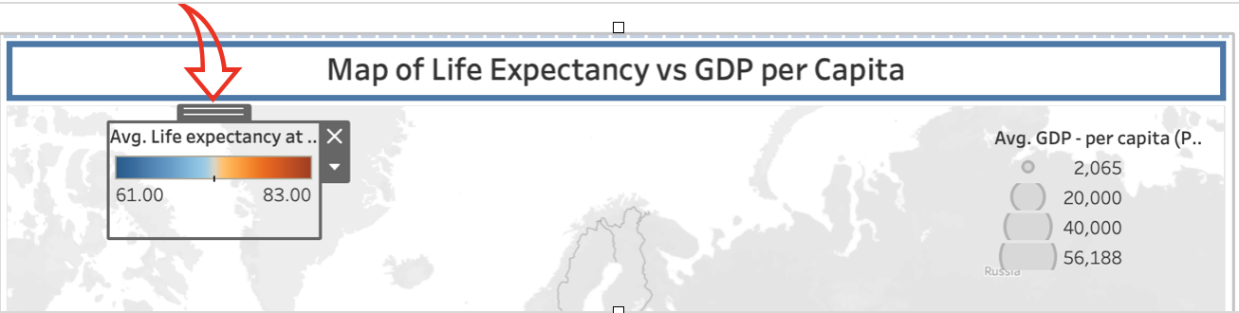
7. I removed the now empty box to the right of the map by clicking on the ‘X’: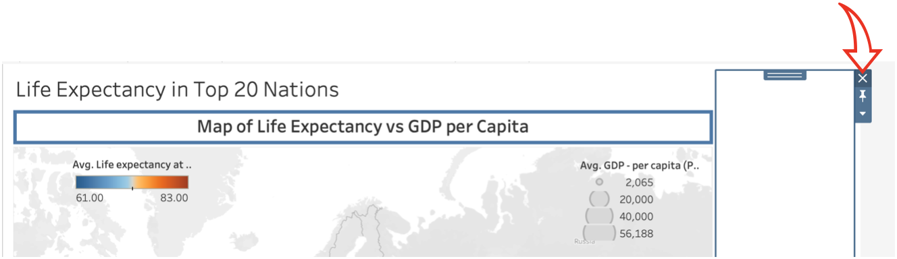
8. I dragged the second visual, ‘Life Expectancy By Country’ into the lower half below the map and then removed the 'Country Legend’ on the right: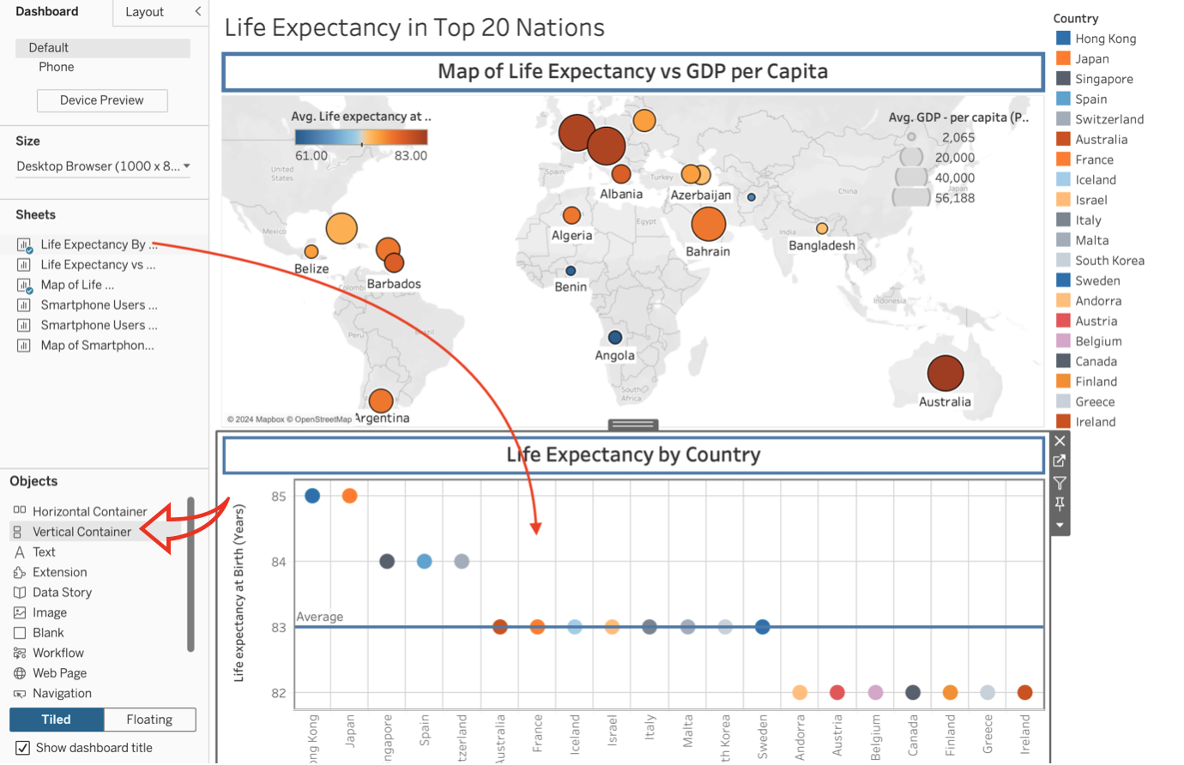
9. Finally, I dragged the third visual to the bottom righthand side below the map and made its legend floating. I positioned and re-sized the legend to fit in the bottom lefthand corner of the chart: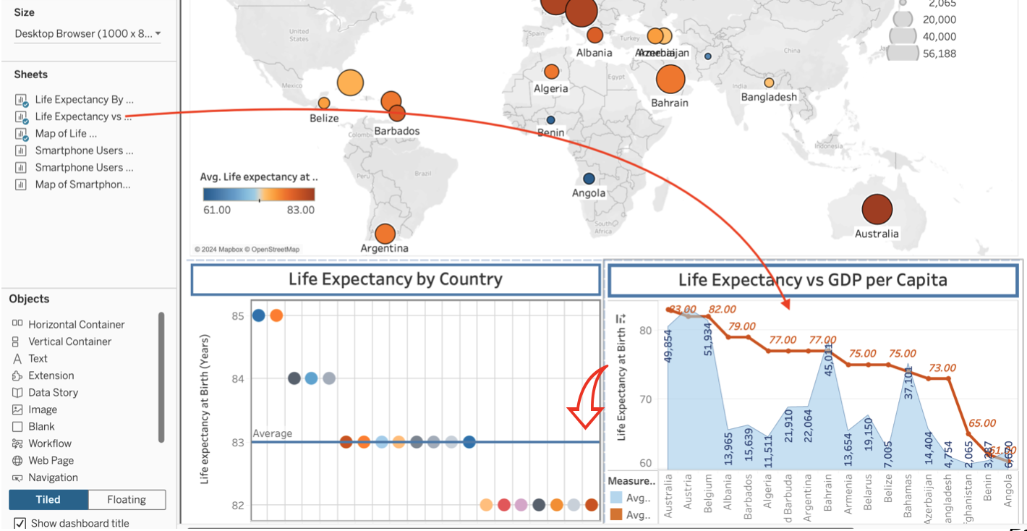
10. I set the device size to ‘Fixed Size’ and ‘Full Screen’ selecting ‘Generic Desktop Monitor’ at the top: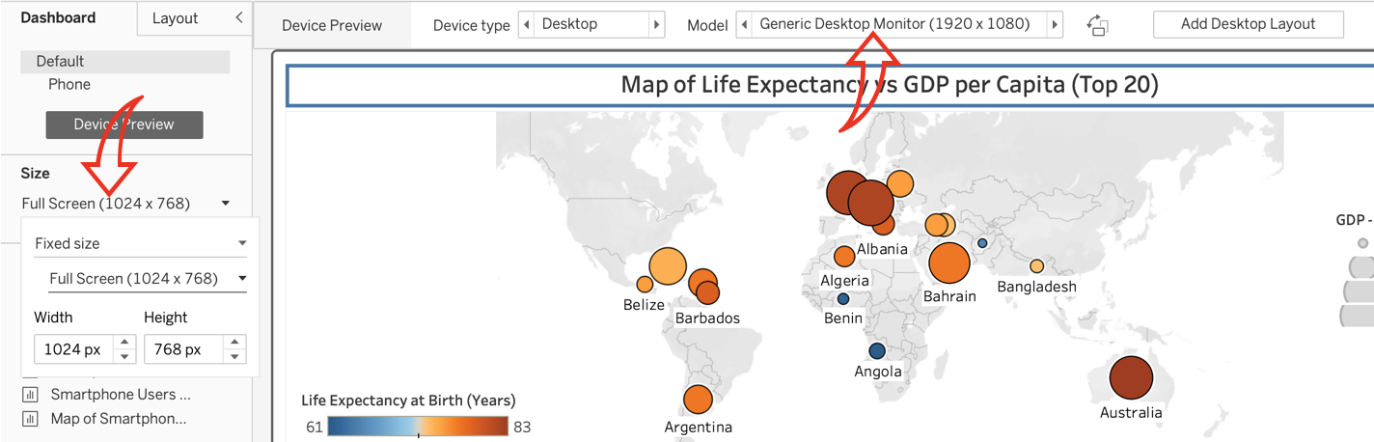
11. I noticed a few issues with data overlapping in my dashboard visuals, so went back to the relevant visuals and re-formatted them until I was happy with the final result: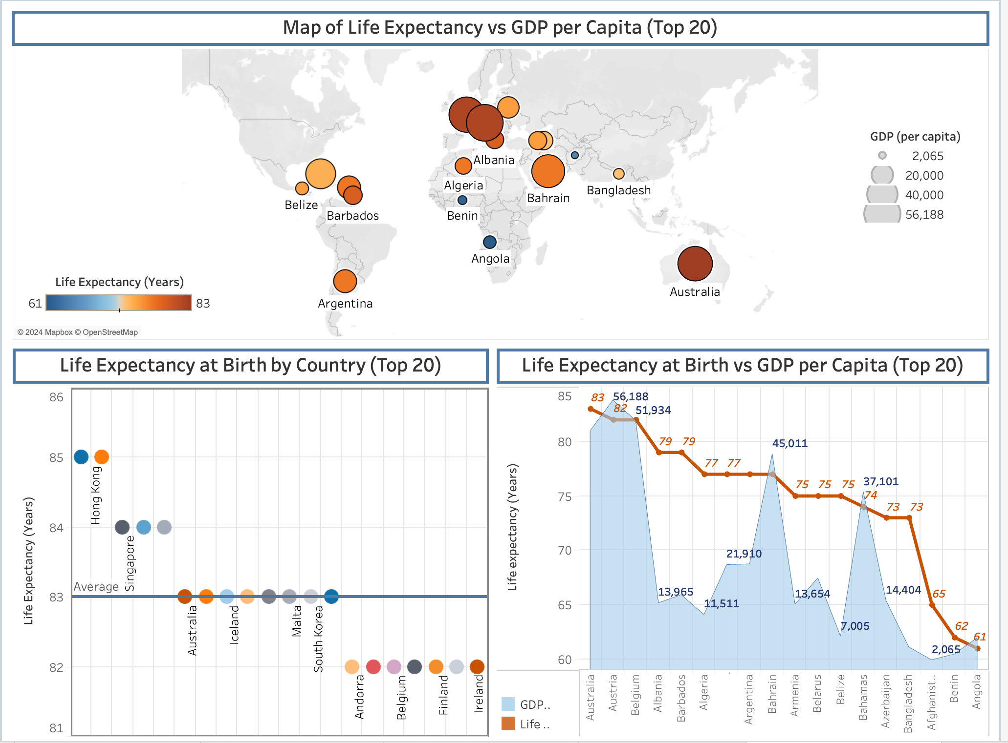
12. I then repeated the same steps to create the second dashboard: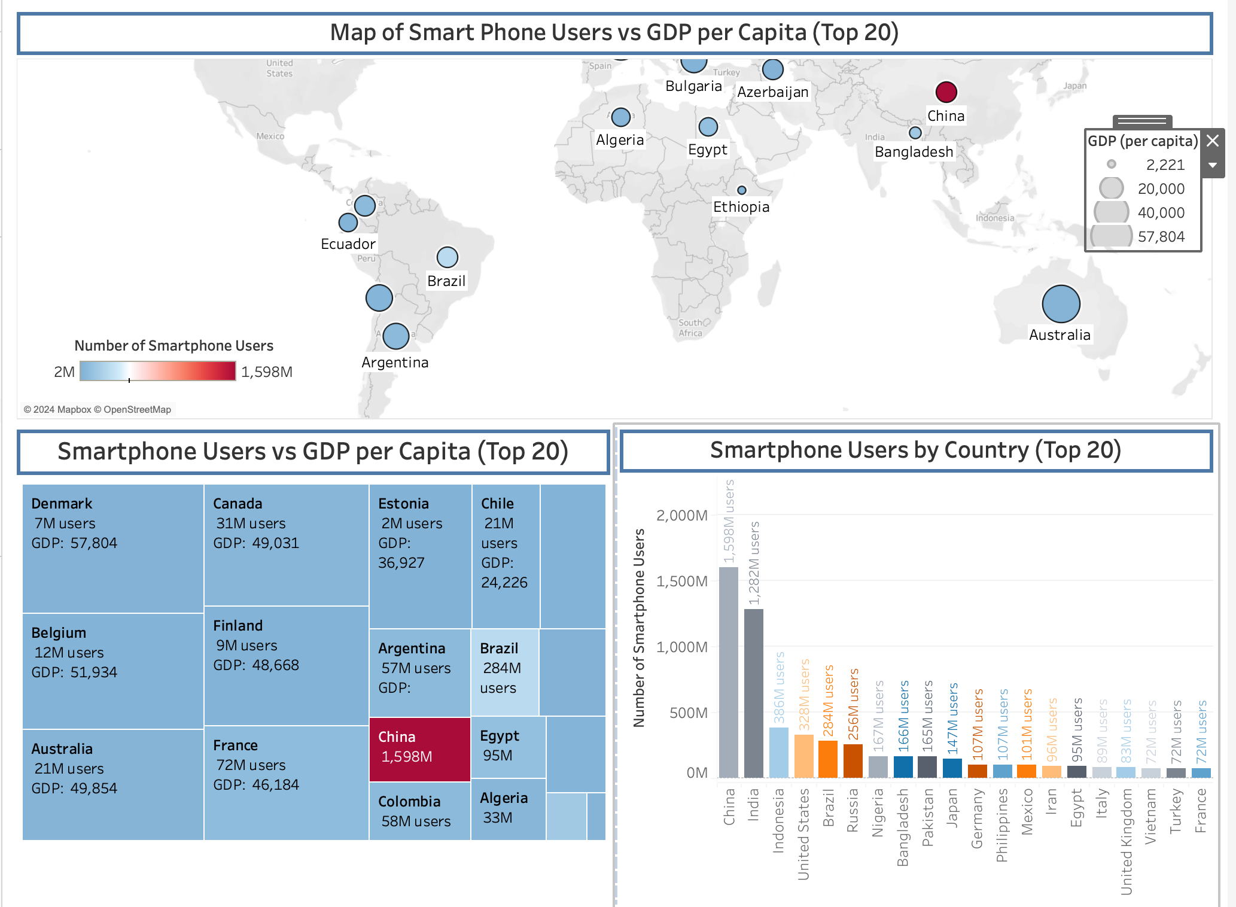

## Step 5 - Creating the Story:

For the final phase, I’m now going to create a Tableau story report consisting of the two dashboards.

1. I started by clicking on the ‘Story’ icon to create a blank story sheet: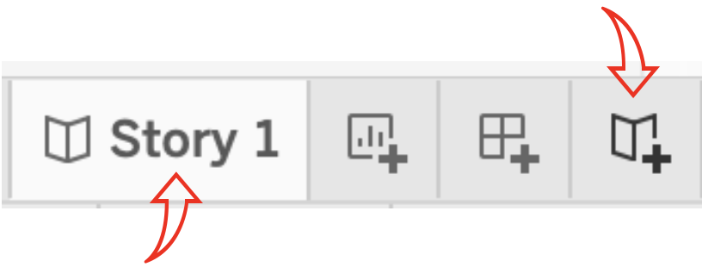
2. I renamed the sheet to ‘Wealth of the Nations’ and dragged the ‘Life Expectancy’ Dashboard to the panel. I also added a caption to the top of the page: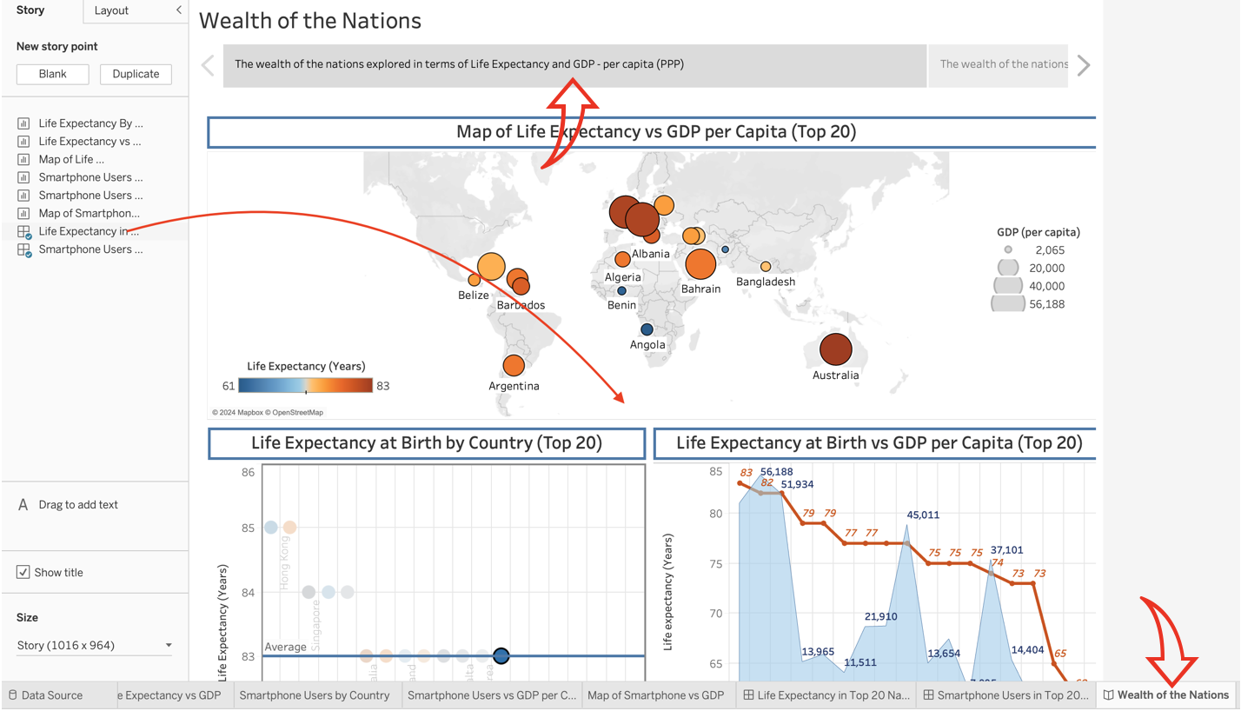
3. To add the second dashboard, I clicked on the ‘Blank’ button under ‘New story point’ and dragged the ‘Smartphone Users’ dashboard onto the panel. I added a second caption at the top: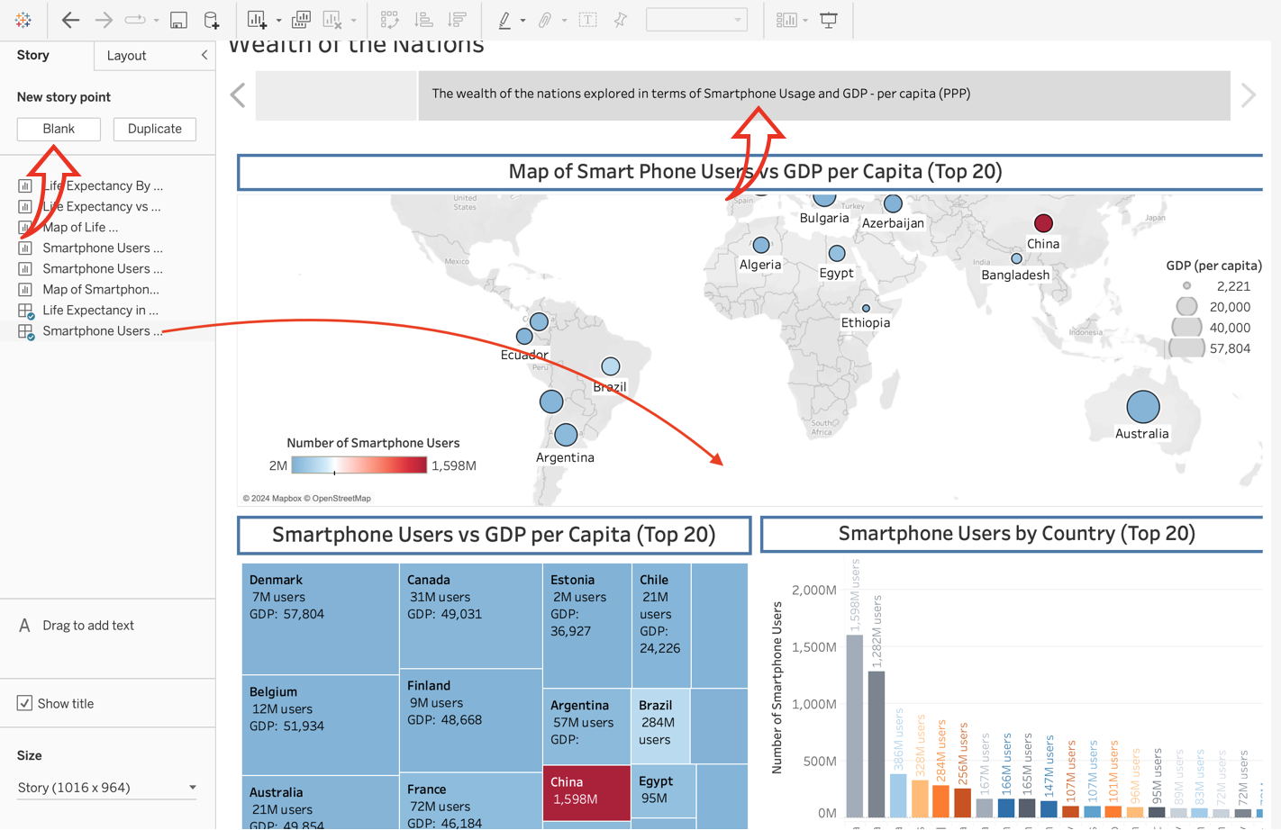

## Conclusion - Publishing the Story:

Once I had completed the story, I published the finished visual data report to my account online at <https://public.tableau.com/app/profile/laureen.pearce/vizzes> so that the client could access it.

# References

*About DAMA UK*. (n.d.). Retrieved from DAMA UK: https://www.dama-uk.org/About-DAMA-UK

*Data Principles, ONS*. (n.d.). Retrieved from Office for National Statistics: https://www.ons.gov.uk/aboutus/transparencyandgovernance/datastrategy/dataprinciples

*Guide to the General Data Protection Regulation (GDPR)*. (n.d.). Retrieved from IT Governance: https://www.itgovernance.co.uk/data-protection-dpa-and-eu-data-protection-regulation

Lindsay Jordan, Stephen Avila. (n.d.). *Data Protection Act 1998*. Retrieved from BCS, The Chartered Institute for IT: https://www.bcs.org/articles-opinion-and-research/data-protection-act-1998/

*The DPA 2018 and UK GDPR*. (n.d.). Retrieved from IT Governance: https://www.itgovernance.co.uk/dpa-2018

Jeffrey Shaffer. (2016) *5 Tips on Designing Colorblind-Friendly Visualizations.* Retrieved from Tableau: <https://www.tableau.com/blog/examining-data-viz-rules-dont-use-red-green-together>

Evelyn Cheng (2021). *China’s census shows population growth slowed.* Retrieved from CNBC: https://www.cnbc.com/2021/05/11/chinas-census-shows-population-growth-slowed.html